

School of Computing, Electronics and Mathematics

PRCO304

Final Stage Computing Project

2015/2016

BSc (Hons) Computing

Holly Voysey

10362533

Help Desk System for Numatic International

Supervisor: Pushpa Subramaniam

Second marker:

# Acknowledgements

This project would have been difficult to complete without the ongoing support and guidance I have received throughout this project. Firstly I would like to express my sincere gratitude to my project supervisor Pushpa Subramaniam, for her excellent guidance and her continued encouragement throughout.

I would also like to thank Numatic International Ltd, for their continued assistance, support and guidance throughout the whole project. In particular to all the staff especially the Information Systems department; who have provided me with support and resources that have allowed me to undertake this project.

# Abstract

This report describes the software development project Numatic International

The report begins with an introduction to the project, detailing the client’s background and problem

Contents

Acknowledgements 1

Abstract 2

1.0 Introduction 5

1.1. Background 5

1.2. Problem Identification 5

1.3. Business Case 6

1.4. Aims and Objectives of Projects 6

2.0 Investigation and Analysis 6

2.1. Initial Research 6

2.2. Analysis Undertaken 7

2.3. Learning Programming Languages 8

3.0 Method of Approach 8

4.0 Legal, social, ethical and professional issues 8

5.0 Project Management 9

5.1 PRINCE2 9

5.2 Scrum – Agile Software Development 9

5.3 Trello 9

Requirements 9

Architecture and Design 10

Unified Modelling Language (UML) 10

Entity Relationship Diagram (ERD) 10

Graphical User Interface (GUI) Design 10

Build Iterations 11

Increment 1 11

Reference List 11

Appendix A – User Guide 11

Appendix B – Project Initiation Document 12

Appendix C – Highlight Reports 18

Appendix D – Stage Plans 18

Appendix E – Exception Reports/plans 19

Appendix F – Supervisor Meeting Minutes 19

Appendix C – Analysis of Numatic’s Current System 21

Appendix D – Questionnaire Results 38

Appendix E – Questionnaire Results Analysis 39

Appendix F – Interview Transcripts 43

Appendix G – Evaluation of Software Development Methodologies 46

Appendix H - Evaluation of Development Technologies 49

Appendix I – ITIL Investigation 51

Appendix J – Off the Shelf Software Solutions 57

Appendix K – GUI / Front-End Design Document 60

Appendix L – Original Entity Relationship Diagram 65

Appendix M – Project Plan and Stage Plans 66

Appendix – Project Fair Poster 66

# 1.0 Introduction

## Background

Numatic International Ltd is a large British manufacturer, well known for designing and manufacturing a wide range of domestic and industrial cleaning equipment, including their iconic Henry vacuum cleaner. Numatic is located on one site in Chard, Somerset, this site is home to every aspect of the business; ranging from goods in, research and development, media, sales, warehousing, manufacturing and shipping. All of these business processes rely heavily upon IT systems, some of these include; the fully integrated network of over 400 PCs, an oracle ERP database system, barcode scanning guns and a warehouse management system.

The Information Systems (IS) department is responsible for maintaining all the systems and hardware used by the business, providing technical support to users around site and developing business improvements. This is vital to ensuring the business can continue to manufacture products and thus continue to make a profit; any downtime to systems can have a detrimental consequences on production, which can incur heavy financial loss. To minimise these risks and manage incidents efficiently a helpdesk system is used; allowing analysts to keep track and monitor all IT problems/issues that need solving. The system also allows t

Currently Numatic uses an off the shelf system, which has been in place for many years, this system has now become inefficient, out dated and no longer meets the needs of the department.

The current helpdesk system used by Numatic is inefficient and used incorrectly for the intended purpose, using an off the shelf software has meant that Numatic has had to adapt their method of working to fit into the current software restrictions. Not only does this slow down members of staff in the department, but often distracts them from concentrating on real issues, the current software is also unhelpful and manual intervention is frequently required to complete tasks. Tasks that should be built into the software have not been done, meaning members of the admin team are required to do additional work. All of these issues mean that the software is hindering staff performance and also decreasing staff morale; having to use a piece of software that has unrealistic ideas.

## Problem Identification

Therefore, Numatic wishes to replace the current helpdesk system, to one which is tailored to Numatic’s unique business model.

used incorrectly for the intended purpose, using an off the shelf software has meant that Numatic has had to adapt their method of working to fit into the current software restrictions. Not only does this slow down members of staff in the department, but often distracts them from concentrating on real issues, the current software is also unhelpful and manual intervention is frequently required to complete tasks. Tasks that should be built into the software have not been done, meaning members of the admin team are required to do additional work. All of these issues mean that the software is hindering staff performance and also decreasing staff morale; having to use a piece of software that has unrealistic ideas.

## Business Case

## Aims and Objectives of Projects

# 2.0 Investigation and Analysis

From the initial problem identification and project objectives, it was clear Numatic required a system that would provide a solution that would meet their business requirements. During the initiation of the project, the client specified what they would like as an end result but did not have any preconceptions or ideas about how this solution would be achieved. As a result, part of the project was about investigating how this would be achieved and not just developing a system or piece of software.

The investigation and analysis section of the project was vital in allowing the author to gain a wider insight into Numatic’s business, helpdesk systems in general and different development techniques. This research and analysis provided a good basis for the rest of the project and particularly in the development of the requirements.

## 2.1. Initial Research

To allow both the author and the client to gain more information about helpdesk systems and system development an in depth investigation was required. This would allow the client to make informed decisions and allow the project to progress, the following topics were investigated:

Off the shelf software solutions - (see Appendix ….)

Whilst the client required a new helpdesk system, they did not define whether the system should be an off the shelf or bespoke system, therefore an investigation into off the shelf systems was done and this was compared to bespoke systems. This allowed the client to view the benefits of both types of software and chose how to proceed with the project. It was concluded that while there were many benefits with pre-built software, it would be cheaper and meet the requirements of the business to choose bespoke software; developed to their needs.

ITIL investigation - (see Appendix …)

During project initiation the client expressed an interest in a helpdesk system that complied with ITIL practises, in order to factor this into the requirements and project, knowledge about ITIL was required. Therefore an investigation of the ITIL practises – particularly the Service Operation section was undertaken, this allowed for understanding of ITIL to be incorporated into the design and development of the system. This will hopefully assist Numatic in moving to an ITIL approach of working in the future.

Development methodologies (see Appendix ..)

Evaluation of different development methodologies, further explained in section 3.0 -Method of approach.

Development technologies (see Appendix …)

Evaluation of different development technologies, further explained in section 3.0 - Method of approach.

## 2.2. Analysis Undertaken

An analysis of Numatic’s business process and the current helpdesk system was done, in order to get a good understanding of what may be required from a new system and to assist in the requirement elicitation process. A variety of different techniques were employed to allow the author to gain as much information as possible, these processes along with the key findings are highlighted below:

Analysis of the current system and business processes - (See Appendix ….)

*Process* – The author spent time at the client’s site, observing not only the current system but also the business processes and the department’s way of working. The current system – SupportWorks ITHD application, was observed in action by users and also used first hand by the author. This, along with discussions with end users, allowed the author to understand any problems with the system and key areas that needed improving. The observation document, provides a detailed analysis into how the system is used at Numatic, key problems with the current system and process models.

*Key Findings* – Numatic was found to be a very unique business, with many of the problems they faced with SupportWorks stemming from the fact that it is an off the shelf application; which is used by Numatic in a way that was not originally intended, meaning many problems have arisen as a result. These problems have led to IS employees disliking the system and often finding it more of a hindrance than helpful.

Questionnaires - (See Appendix … and ….)

*Process* – Questionnaires were given to all employees in the IS department, allowing the author to collect end user feedback; from this sample 11 completed questionnaires were returned. A mixture of open and closed questions were used, giving the respondents the opportunity to give their full opinion on the current system and allow possible suggestions for future development. Once the completed questionnaires were returned, the results were analysed to find trends and important findings.

*Key Findings* - Users agreed the design could be improved in SupportWorks (current system) along with call management, due to calls often being hard to find. When asked what the most important features of a new system was, the design was again stated as being significant, with respondents saying it should be user friendly, initiative and simple.

Interviews - (See Appendix …)

*Process* – Informal interviews were undertaken with all managers in the IS department, this was due to a large number of end users and time constraints and included the database, development, networking and projects and admin managers. Open questions allowed a large quantity of qualitative information to be extracted, which was particularly helpful for the development of requirements for the new system.

*Key Findings* – The main pain points of SupportWorks come from over complicated processes and therefore a new system should be simple. A way of differentiating between the types of tickets would be very beneficial to end users, in particularly for managers.

## 2.3. Learning Programming Languages

After investigating and agreeing with the client on chosen development technologies, it was then down to the author to learn it, in order to be able to develop the system. Time to learn, research and prototype these development technologies were factored into the plan, ensuring there would be a suitable time frame to develop the system. Researching and learning PHP/ MySQL also allowed the author to have a better understanding of the development of the system, ensuring that in the development of the system requirements, all of the specified requirements could be achieved.

The following tutorials, websites and sources were found to be particularly helpful in the development of the system:

* W3Schools
* Lynda.com
* YouTube

# 3.0 Method of Approach

Describe + justify approach – refer to development methodologies, development technologies

Risk management

# 4.0 Legal, social, ethical and professional issues

# 5.0 Project Management

## 5.1 PRINCE2

Prince2 – Projects IN Controlled Environment 2nd Version, is currently one of the most widely recognised and practised project management methodologies in the UK and worldwide (ref). PRINCE2 was revised in 2009 to include aspects on tailoring it to the appropriate environment and scale of project (Ferguson and Novare Consulting, 2011).

PRINCE2 was tailored to this project, by using a small subset of the methodology, this included using the following aspects (these can be seen throughout the project and in the Appendix):

* Project brief – the project proposal
* Project Initiation Document (PID) –derived from project brief and includes business justification of the project commencing.
* Project plan – High level overall plan, showing major deliverables
* The use of stages/ stage planning
* Highlight reports – 7 highlight reports completed weekly during 11/02/16 – 17/05/16 and review meetings were held
* Risk management -
* Exception reports and plans –
* Quality management
* Communication plan
* Project closure – End of project report

## 5.2 Scrum – Agile Software Development

## 5.3 Trello

Trello is a web-based project management application and was used throughout the project as a tool to assist in the overall management.

# Requirements

# Architecture and Design

Once the initial requirements were developed and signed off by the client the design phase could begin

## Unified Modelling Language (UML)

## Entity Relationship Diagram (ERD)

Once the requirements, Use Case and UML models, the database could be designed. The ERD defines the relationships between the attributes within the database. The tables are explained below:

* Ticket
* Customer – Stores information about the customer who the ticket is created for.
* Department – Allows the
* Priority –
* Update -
* Analyst – Stores information about the analysts using the system.
* Watched – This table stores information regarding tickets that analysts have add to their ‘watched’ list.

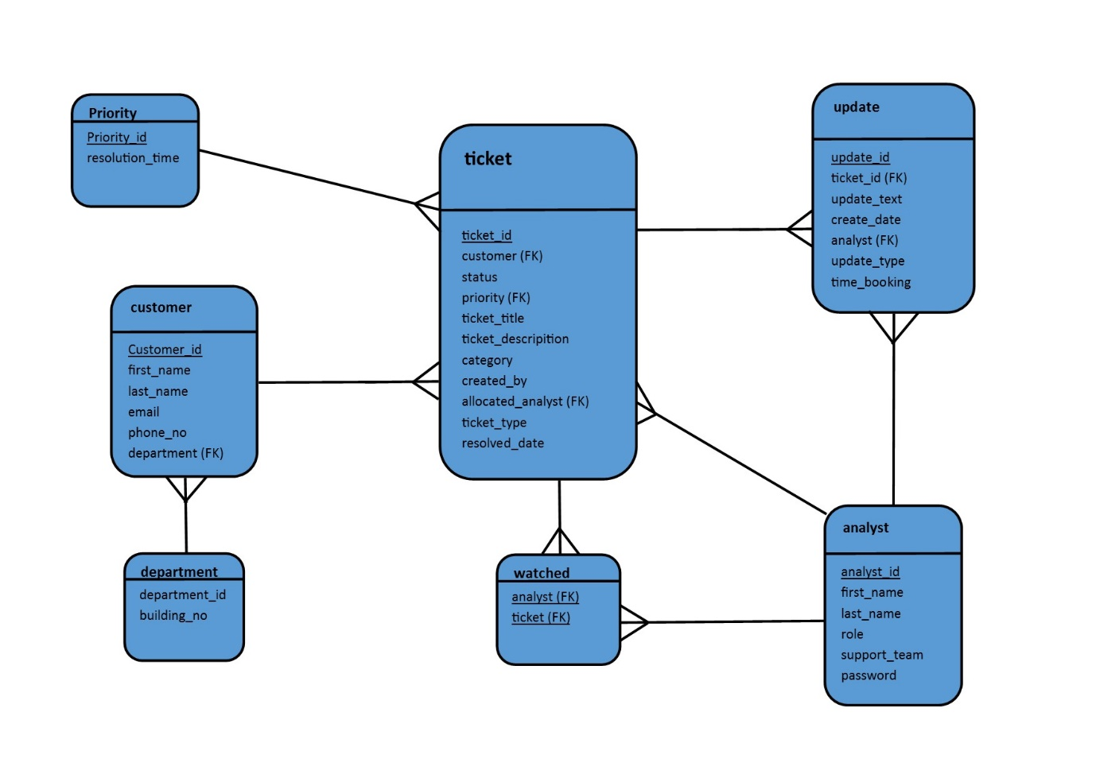

## Graphical User Interface (GUI) Design

Stage 3 of the project was focused towards designing and developing the user interface of the system, this stage required a high level of user interaction.

Client Meeting – Initally

# Build Iterations

## Increment 1

Increment 2

An overview of the project is given to inform the reader about the project, the company background and some of the existing problems within the company, that will be resolved by building a new system to well defined objectives.

**Word Count:**

# Reference List

Ferguson, C. and Novare Consulting, (2011). *PRINCE2® for small-scale projects*. The Stationery Office.

# Appendix A – User Guide

# Appendix B – Project Initiation Document

**1. Introduction**

Numatic International Ltd is a large company that designs and manufactures a wide range of domestic and industrial cleaning equipment, including their iconic Henry vacuum cleaner. Numatic International is based entirely on one site, located in Chard, Somerset. This site is home to every aspect of the business; ranging from goods in, research and development, media, sales, warehousing, manufacturing and shipping. All of these business processes rely heavily upon IT systems, such as, the fully integrated network of over 400 PCs, an oracle ERP database system, barcode scanning guns and a warehouse management system. The Information Systems (IS) department must therefore be as efficient as possible, ensuring the business can continue to produce products; many of which are in high demand. To do this a helpdesk system is used to manage IS employee’s time and allow them to keep track and monitor all IT problems/issues that need solving. As well as booking time to allow the IS manager to track employee resources. The current helpdesk system used within the IS department, has become outdated and no longer meets all the needs of the department. Therefore, Numatic wishes to replace the current helpdesk system, to one which is tailored to Numatic’s unique business model.

**2. Business Case**

**2.1 Business Needs**

The current helpdesk system used by Numatic is inefficient and used incorrectly for the intended purpose, using an off the shelf software has meant that Numatic has had to adapt their method of working to fit into the current software restrictions. Not only does this slow down members of staff in the department, but often distracts them from concentrating on real issues, the current software is also unhelpful and manual intervention is frequently required to complete tasks. Tasks that should be built into the software have not been done, meaning members of the admin team are required to do additional work. All of these issues mean that the software is hindering staff performance and also decreasing staff morale; having to use a piece of software that has unrealistic ideas.

**2.2 Business Objectives**   
To develop a new helpdesk system and improve the related business processes, which will:   
(a) Improve the efficiency and accuracy of analysts interactions,  
(b) Remove the need for additional manual tasks to be carried out,  
(c) Reduce additional cost of the business – reducing maintenance and licence fees.

(d) Provide a user friendly and consistent approach to incident management   
(e) Move to an ITILL approach to service management

**3. Project Objectives**

**1. Analysing business processes**To analyse the existing business processes and procedures along with the current helpdesk system, allowing a good understanding of the business to be gained, thus, allowing recommendations for improvement to be given. Investigating the ITIL practices and how it will apply to a new system and method of working at Numatic, showing the benefits to the client.

**2. Identify user requirements**Develop user requirements from the analysis stage, following the relevant ITIL principles and working with the client to identify and document a set of requirements – with their approval. To then prioritise these requirements and to develop the list further should changes be required after further communication and through iteration development.

**3. Evaluate potential technologies**To analyse potential development technologies and deployment solutions, whilst considering any requirements Numatic may have.

**4. Design the system**Investigate and explore different designs, in order to develop front and back end designs, which the client is happy with. Design the interface following HCI principles, which will also follow Numatic’s style and themes.

**5. Implement a solution**To implement the new service/helpdesk system in line with new processes, specified ITIL practises and user requirements.

**6. Provide staff training**Provide staff with adequate training and user documentation.

**4.0 Initial Scope**

1. Current business processes along with the current system will be analysed, with the weaknesses identified. This will be done with the use of interview, questionnaires and observation, the use of UML will also be used to document the processes.

2. A new system will be developed, which will (Further requirements will be developed):

* Replace the current system
* Be used for the management of tickets, allowing tickets to be created, updated, deleted and closed
* Allow the user to create an update assigned to a ticket
* Allow users to book time to a specified ticket
* Allow users to assign tickets to other analysts
* Search functionality for finding tickets
* The ability to watch favourite tickets
* Allow individual analysts to log into the system
* Used only onsite at Numatic

3. User requirements will be elicited from interaction with the client, methods including, interview, questionnaires and observation. This will allow user stories to be developed to help further understand requirements. Requirements will then be prioritised using the MoSCoW method.

4. Further user requirements will be elicited as the project develops, using an agile approach.

**5.0 Method of Approach**

An agile software development methodology will be used, taking an iterative approach will allow the requirements and the system to develop throughout the project. Each iteration, will develop the system achieving more of the requirements list, the requirements will be prioritised using the MoSCoW method.

A web application will be developed therefore possible technologies may include PHP/MySQL or ASP.Net/SQLServer for the Back-End and HTML/ CSS for the design of the Front-End. Full evaluation of possible methodologies and technologies will be investigated throughout the project, to ensure the most appropriate solutions are selected for the project.

**6.0 Initial Project Plan**

|  |  |  |  |
| --- | --- | --- | --- |
| **Overall Project Plan** | | | |
| **Stage** | **Expected Start Date** | **Expected Completion Date** | **Deliverables/ Products** |
| 1. Feasibility study and Initiation |  | 12 Dec | Project Proposal,  PID |
| 2. Investigation, analysis and requirements | 1 Feb | 10 Feb | Analysis of business processes,  Current system analysis,  Requirement documents,  Investigation of ITIL practises,  Evaluation of possible development techniques,  Basic Prototype |
| 3. GUI/ Front- End Design | 11 Feb | 17 Feb | Front end and GUI designs – Client feedback and approval |
| 4. Back-End Design | 18 Feb | 24 Feb | Design documents - DB schema |
| 5. Increment 1 | 25 Feb | 2 Mar | Sub system with ‘Must have’ requirments |
| 6. Increment 2 | 3 Mar | 9 Mar | Further anylsis and development of the system |
| 7. Increment 3 | 10 Mar | 16 Mar | Further anylsis and development of the system |
| 8. Increment 4 | 17 Mar | 23 Mar | Finished working system with all required functionality, with well-designed front end interface. |
| 9. System and user acceptance testing | 24 Apr | 29 Apr | Final System,  User guide and training |
| 10. Assemble and complete final report | 30 Apr | 6 May | PRCO304 Report |

Contingency time has been added between section 8 and 9. As this is the Easter holiday time period. Nothing is planned during time period; however, if project is not on schedule further development can be done.

Stage 2 plan:   
This contains further details of tasks to be carried out.

|  |  |  |  |
| --- | --- | --- | --- |
| **Stage 2 plan** | | | |
| **Task** | **Start** | **End** | **Deliverables/ Products/Outcome** |
| Analysis of current business process and current system | 1 Feb | 4 Feb | Documentation of the business and system; discussing pros and cons.  Interview transcript,  Questionnaires,  UML diagrams, Investigation of ITIL practises,  Other analysis documents |
| Requirement elicitation and specification of requirements | 5 Feb | 6 Feb | Requirements document |
| Requirement validation | 7 Feb | 8 Feb | Client agreement and sign off  Meeting with client |
| Evaluation of possible development technologies | 9 Feb | 10 Feb | Report discussing different possible technologies, with reasons of chosen technology |

**6.1 Control Plan**

The use of the PRINCE2 methodology and control techniques will ensure the supervisor is aware of the project’s progress. The following techniques will be implemented:

* Risk management – Section 7
* Communication plan – Section 6.2
* Quality plan – Section 8
* Highlight reports - Weekly until Easter
* Stage reviews – At the end of each stage
* Project supervisor meetings – As agreed with my supervisor
* Exceptions reports/plans - Produced should the deviation to the plan exceed the previously agreed limit.

**6.2 Communication Plan**

Throughout all stages of the project, meetings with the project supervisor will occur on a regular basis, to discuss the project development and any risks or problems that have arisen; these will be based upon Highlight reports produced every week. At the end of each stage there will be a review and feedback session, allowing feedback to be given as well as discussing the planning of the next stage and of technical deliverables. Meetings will also be scheduled to discuss major deliverables such as the PID and draft final report.

Regular discussions will also be scheduled with the client, particularly during the beginning of the project, requirement elicitation, design and development of the software; thus ensuring the client’s objectives are being met. These communications will be carried out via email and face to face meetings.

**7.0 Initial Risk List**

Detailed below are a list of potential risks, their likelihood and the potential severity to the project. Management strategies have been detailed suggesting how these risks will be dealt with.

|  |  |  |  |
| --- | --- | --- | --- |
| **Risk** | **Potential Impact** | **Possibility**  **(H/M/L)** | **Management Strategy** |
| Schedule Overrun | Medium -Large | High | Planning and the use of good project management techniques will ensure the monitoring of the project. Contingency time will be added to the plan; an exception plan will also been developed to plan for deviation. Using the MoSCoW requirement prioritisation and an Agile approach to development, means a slippage in the schedule, will have less of a devastating consequence. |
| High workload levels | Medium | High | Use priority setting techniques, with clear goals set out throughout the project, keeping a sense of urgency. Allow contingency time, for any emergencies. |
| Loss of key personal (Illness/Sickness) | Large | Low | Unpreventable would require to withdraw from the project or may involve extenuating circumstances. |
| Difficulty learning/using development technologies | Medium | Medium | Investigation into the development technology will take place and the development of a prototype will ensure project is viable. Learning time will also be factored into the planning. |
| Requirement breakdown (Disagreement by stakeholders) | Medium | Medium | Prototyping can be used to illustrate to stakeholders the requirements. Where a decision cannot be resolved, the IS Manager will make the final decision. |
| Late changes to requirements | Medium | Medium | The use of sprints allows a certain scope for requirements to be changed. |
| Client withdraws from project | Medium | Low | Ensuring client is fully involved with the project to reduce likelihood of them withdrawing. Ensuring requirements specification is developed early in the project, meaning if they did withdraw, the project could still be continued. |
| Specification Breakdown | Medium | Low - Medium | Get the functional specification signed off and agreed to by client, constantly keep client involved through development. Checking regularly what has been developed in what is expected. |
| Conflict of proposed outcome/ designs | Medium | Medium | Discussions with end users; employees, line-managers and the IS Manager will take place. The overall decision will be with the IS Manager. |
| Management of change | Low | Medium | User guides will be written on the new system and extensive training will be carried out; ensuring the system is used correctly. |
| Gold plating (developing unnecessary features) | Medium | Low | Ensuring the plan will be followed and using an action log containing requirements to be completed will keep development on track. |
| Technology Failure | High | Low | Standard technologies will be used; back-ups of all project material will be taken regularly. |

**8.0 Initial Quality Plan**

|  |  |
| --- | --- |
| **Quality Check** | **Strategy** |
| Project proposal | Project proposal will be checked, by client to ensure project is starting out on the correct path and they are happy with the proposed project to go ahead. |
| Requirements | Requirements will be examined and checked to ensure they met the business’ targets and objectives. They will also be checked to confirm they will be achievable and demonstrable. Analysis of current system, prototyping, user interviews and walkthrough will be employed. |
| GUI Design Validation | Designs will comply with HCI principles and will be checked by client to ensure it complies with company style. |
| System Design Validation | Designs will be checked to ensure they comply with software development principles. (DB normalisation, software design principles etc.) |
| Sub-system usability and validation | Testing will be completed throughout development and at the end of each increment. |
| Final system and user acceptance | Full testing will be completed during the Testing Stage. |

# Appendix C – Highlight Reports

# Appendix D – Stage Plans

The overall project plan as defined in the PID. This was used as a basis to create more detailed individual stage plans, which are detailed below.

|  |  |  |  |
| --- | --- | --- | --- |
| **Overall Project Plan** | | | |
| **Stage** | **Expected Start Date** | **Expected Completion Date** | **Deliverables/ Products** |
| 1. Feasibility study and Initiation |  | 12 Dec | Project Proposal,  PID |
| 2. Investigation, analysis and requirements | 1 Feb | 10 Feb | Analysis of business processes,  Current system analysis,  Requirement documents,  Investigation of ITIL practises,  Evaluation of possible development techniques,  Basic Prototype |
| 3. GUI/ Front- End Design | 11 Feb | 17 Feb | Front end and GUI designs – Client feedback and approval |
| 4. Back-End Design | 18 Feb | 24 Feb | Design documents - DB schema |
| 5. Increment 1 | 25 Feb | 2 Mar | Sub system with ‘Must have’ requirments |
| 6. Increment 2 | 3 Mar | 9 Mar | Further anylsis and development of the system |
| 7. Increment 3 | 10 Mar | 16 Mar | Further anylsis and development of the system |
| 8. Increment 4 | 17 Mar | 23 Mar | Finished working system with all required functionality, with well-designed front end interface. |
| 9. System and user acceptance testing | 24 Apr | 29 Apr | Final System,  User guide and training |
| 10. Assemble and complete final report | 30 Apr | 6 May | PRCO304 Report |

Stage 2 plan:

|  |  |  |  |
| --- | --- | --- | --- |
| **Stage 2 plan** | | | |
| **Task** | **Start** | **End** | **Deliverables/ Products/Outcome** |
| Analysis of current business process and current system | 1 Feb | 4 Feb | Documentation of the business and system; discussing pros and cons.  Interview transcript,  Questionnaires,  UML diagrams, Investigation of ITIL practises,  Other analysis documents |
| Requirement elicitation and specification of requirements | 5 Feb | 6 Feb | Requirements document |
| Requirement validation | 7 Feb | 8 Feb | Client agreement and sign off  Meeting with client |
| Evaluation of possible development technologies | 9 Feb | 10 Feb | Report discussing different possible technologies, with reasons of chosen technology |

Stage 3 plan:

# Appendix E – Exception Reports/plans

# Appendix F – Supervisor Meeting Minutes

**Meeting 1**

**Date:** 13/11/15  
**Time:** 15:00 -15:30  
**Supervisor:** Pushpa Subramaniam

**Items Reported:**

* Project Proposal

|  |
| --- |
| Discussion Content: |
| * Discussed and got clarity over my proposal * Discussed nature of technologies and development methodologies. * Had my concerns about using PHP and MySQL, however, I will set aside some time to learn PHP. * Discussed the structuring of the requirements. * Discussed the use of Trello in my project. |

|  |  |  |
| --- | --- | --- |
| Action | Actioner | Due Date |
| Complete draft PID and email it for feedback | HV | 01/12/15 |
| Investigate Trello tool | HV | N/A |

**Meeting 2**

**Date:** 11/12/15  
**Time:** 12:30 -13:00  
**Supervisor:** Pushpa Subramaniam

**Items Reported:**

* Project Initiation Document - Draft

|  |
| --- |
| Discussion Content: |
| * Discussed draft PID * Reviewed the dates in the initial project plan of the PID * Discussed how ITIL principles will be incorporated into the project and how it will be evidenced. * Discussed PRCO304 guidelines. |

|  |  |  |
| --- | --- | --- |
| Action | Actioner | Due Date |
| Amend PID and submit for approval | HV | 15/12/15 |
| Supervisor reviews PID | PS | 18/12/15 |

# Appendix C – Analysis of Numatic’s Current System

**Information Systems Department Overview**

The Information Systems (IS) department currently have approximately 20-30 employees. Covering network and user support, database administration, infrastructure support, system development, business analysis and IS functional support to the other areas of the business. The services provided by the IS department have significantly changed over the past couple of years; with the focus changing to managing and developing projects that offer business improvements, instead of just solving technical issues. It is therefore hoped that a new system will enhance the efficiency of the department further and help with the management of resources.

**Business Process**

I have observed and recorded the IS department’s usage of the current system. The Activity Diagram (Fig.1) below highlights the workings of the current system; showing the business process behind it and how the system is used within the department. The diagram can also be used to help identify any potentially problematic parts of the system or areas of the process.

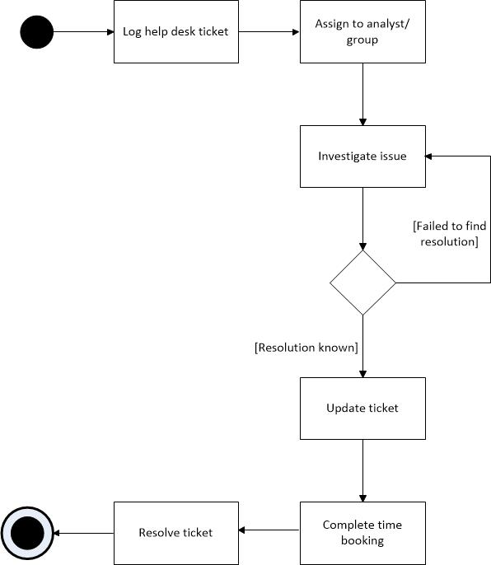

Fig 1. Activity Diagram of current system

**Current System**

**Introduction into the system**

Numatic International are currently using ‘SupportWorks ITHD’ application, created by Hornbill Systems; this is a high level ticketing and issue tracking system, designed for use in help desk and information technology (IT) environments. The system provides straightforward call management functionality to the helpdesk and assists with the management of projects and development to systems. The SupportWorks client is a desktop application, which uses a Microsoft SQL database backend.

Numatic has been using this system for approximately 5 years, although, it is a commercial off the shelf system, there have been varying degrees of customisations to the application to help it meet the changing needs of the department. Numatic now require a new system to replace the current one, this would help further meet the needs of the business.

Numatic are currently using SupportWorks for two main objectives; managing calls (tickets) on the helpdesk and tracking employee activities and resources, along with a number of other functions. These are investigated further below:

**Call Management**

Calls (tickets) are difficult to manage in SupportWorks, as there is no concept of call classes. Therefore all calls are currently logged as incidents; with the call type of ‘helpdesk’. Meaning there is nothing that distinguishes between an incident and those calls that stay open indefinitely or for projects/ changes to the business.

Incidents are predominantly logged from telephone calls to the IS support desk (70% of the time) with the reminder calls being logged by emails sent directly to the IS helpdesk email. These incidents are then assigned to an analyst in the network support team, they are then investigated and fixed; these calls are normally resoled within a few days to a week. There are approximately between 5-20 incidents logged to the helpdesk every day. They are logged from users in every aspect of the business and are customer based in the fact that a particular user requires something to be fixed/ done.

Tickets are also logged by members of the IS team to track the development of systems and to manage projects within the department. This allows members of the project to be aware of how it is progressing, due to all updates regarding that particular project being contained in the same record.

The management of employees is also done through tickets, currently there are many calls open that are for tasks that occur on a regular basis or for general activities, such as daily backs up and network management. This allows employees to book time to tasks which may not be directly related to a specific call, such as a team meeting.

**Time Booking and Employee Management**

The IS Manager uses SupportWorks to extensively track the time analysts spend working on calls and projects. Analysts are required to update calls with details of what was worked on, along with the time spent on that particular call. Time bookings can also be back dated to the previous week, so that the accurate time is recorded.

The reporting functionality is also used in conjunction with the time bookings, allowing weekly reports to be ran, showing the time booked per analyst or per call. Providing useful documentation for managers to review employee resources and to plan future resources. This feature however, does not provide the IS manager with the exact information he would like meaning members of staff in the admin team have to complete additional manual work to collect this information.

This is one of the most used features of the system used by Numatic, and the information is used to work out utilisation against projects and calls. With the aim of allowing more resources to be working on high level projects and urgent matters. The projects and admin team also find the time booking data helpful, time bookings from previous projects and calls help to make more precise and realistic estimates for future project planning.

Using SupportWorks as a method of booking time is an example where the system is used for a purpose which it was not originally intended for. Whilst the system allows time to be booked to particular calls, it was not developed as a time booking system, expecting staff to book all of their time to certain projects, calls and tasks worked on during a particular day.

**Usage Statistics**

Since Supportworks has been used at Numatic there have been over 12,000 calls logged; of these calls there are currently about 450+ open calls. Many of these calls are permanently open and contain tasks to be completed daily, such as the ‘F0003191 – Undertaking of daily back ups’.

Below shows a chart (Fig. 2) analysing all the tickets that are currently open in the current helpdesk for each department or sub department, it also shows the type of call that has been logged. From this table it is clear that there are very few incidents (problems); 8% of all open calls. It also shows there are many more changes or management type of calls, which are linked to projects being undertaken within the department; 33.7% are calls with the class ‘change’. It also shows the large quantity of tickets that are open in this system. In the average helpdesk there are approximately 160 calls open, Numatic have about 3 times that figure with 486 calls open.

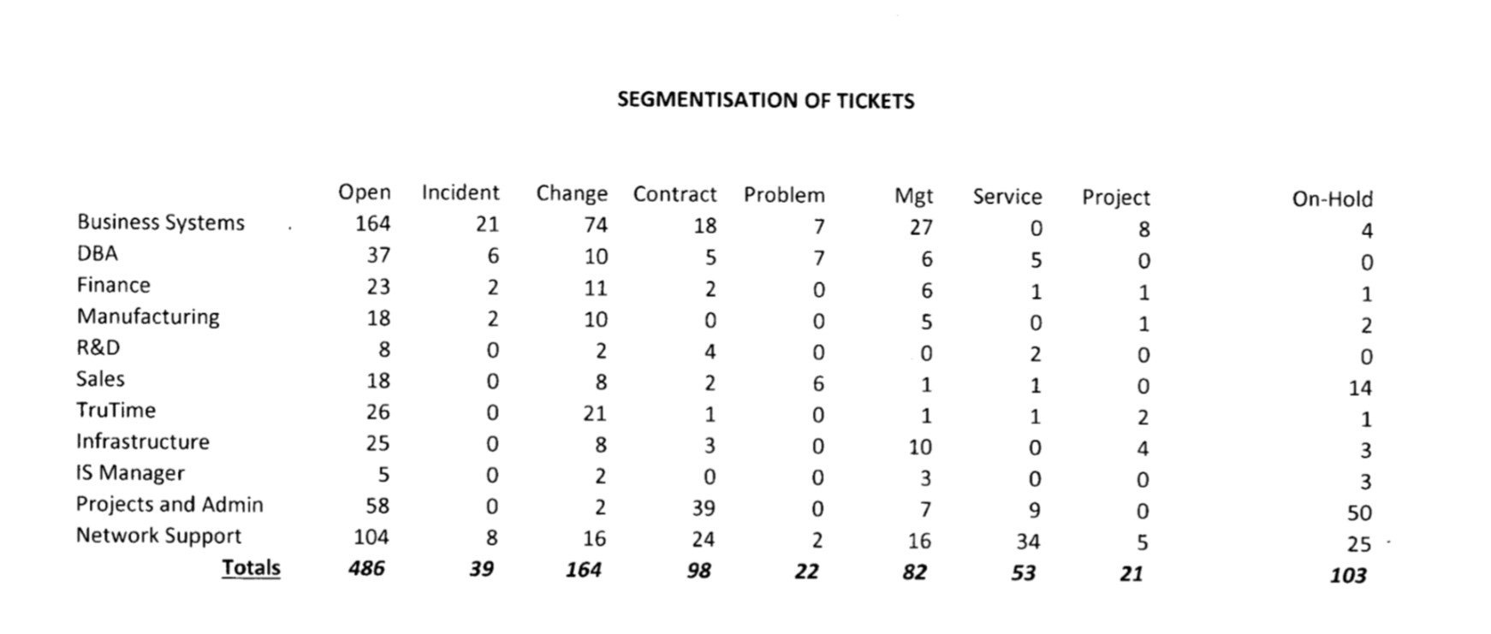

Fig 2. Segmentation of tickets

**Problems of current system**

There are many problems with the current system, due to the system not being tailored to the needs of the department and also stemming from the way the system is used.

A lack of staff training, has resulted in many calls not being logged; due to analysts not having enough time or deeming the problem to not be a big enough issue to be logged; such as resetting a password or another ‘quick fix’ solution. A lack of training has also meant that some features of the system are not used at all; workflows are not used and are instead users just reassign the call to another analysts. Some analysts do not use SupportWorks as often as required; leading to, many calls not be accepted and calls not being kept up to date. This means that often managers will have to chase up analysts for updates, instead of getting the required information directly from the call, thus wasting time unnecessarily.

These problems mean that tasks are sometimes forgotten or missed and that it is difficult for management to fully investigate any common repeating issues. It also makes booking time problematic and often leads to analysts booking time to a general call, such as ‘Helpdesk – quick fixes’.

Many of the issues, however, are not down to the users or a lack of training and instead is due to the design of the system. Whilst undertaking the observation and investigating the system, I was made aware of some particular issues and problems that the users face in the use of the system. These issues have been then further analysed and investigated, I have included some examples of these issues, with screenshots below:

The call class is not used correctly, as every call is a ‘helpdesk’ type. Even though this is not the case as many of the calls are project or development related tasks. Ideally different calls would have an appropriate class for the different type of calls, such as, incident, change, problem and management. This would allow analysts to easily see what type of calls they had open and possibly filter down calls on the call class.

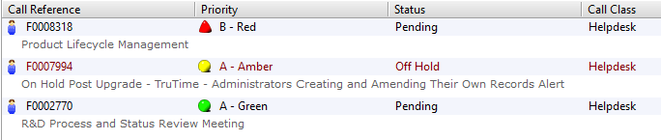

For example the ‘Product Lifecycle Management – F0008318’ call has been open since the 03/08/2012 and is used to manage the PLM project and collect time booking information. This call would not be classed as ‘helpdesk’ within the IS department, yet it is not given a more relevant call class.

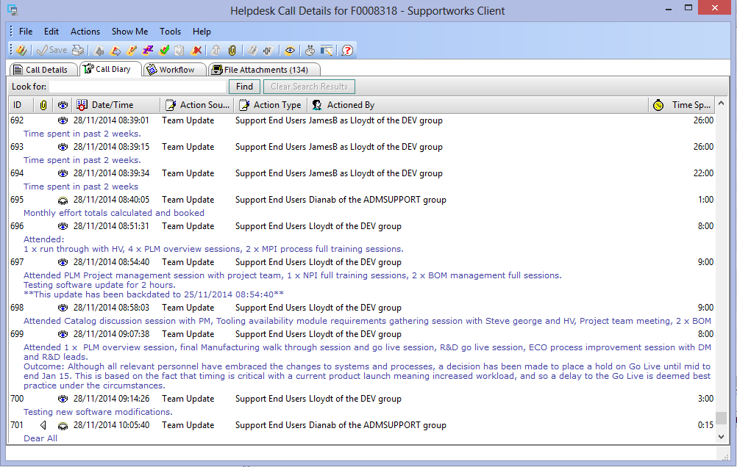

The larger projects/ tasks are often hard to keep track of in the system, due to large quantities of updates being done mainly for time booking purposes as opposed to informative updates. These updates are not helpful and just make it harder to find updates due to the large number of time bookings (Oracle R12 and BI Upgrade – F0012335):

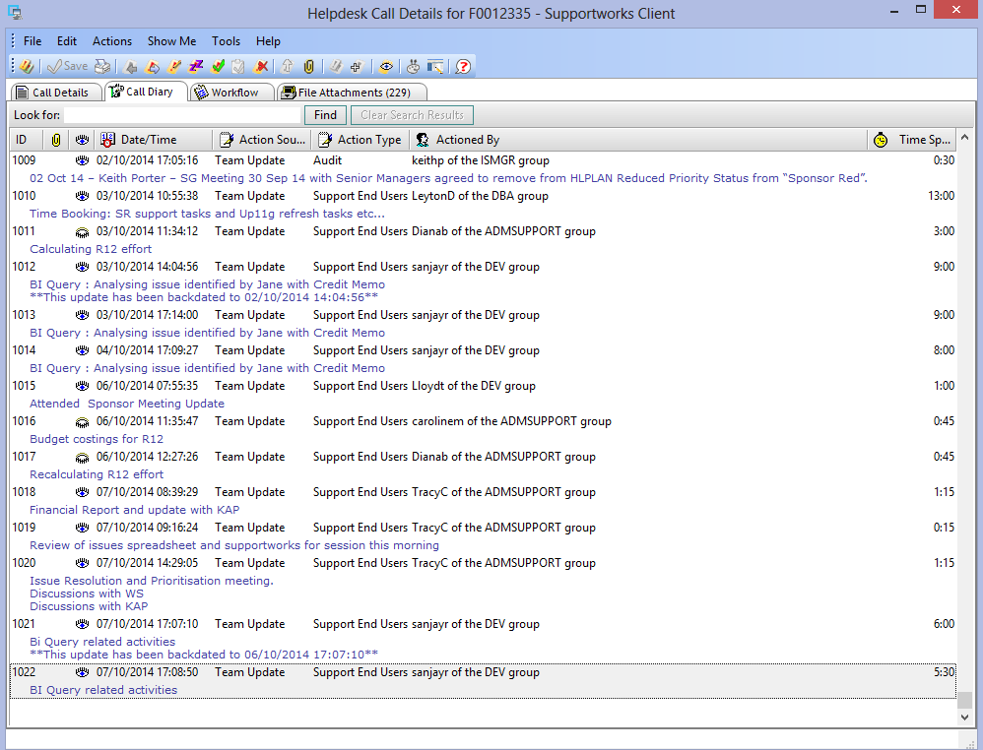

Post R12 Post Implementation User Issues – F0012655, which again shows many time booking updates. As the update text field is compulsory the update is often not informative and pointless:

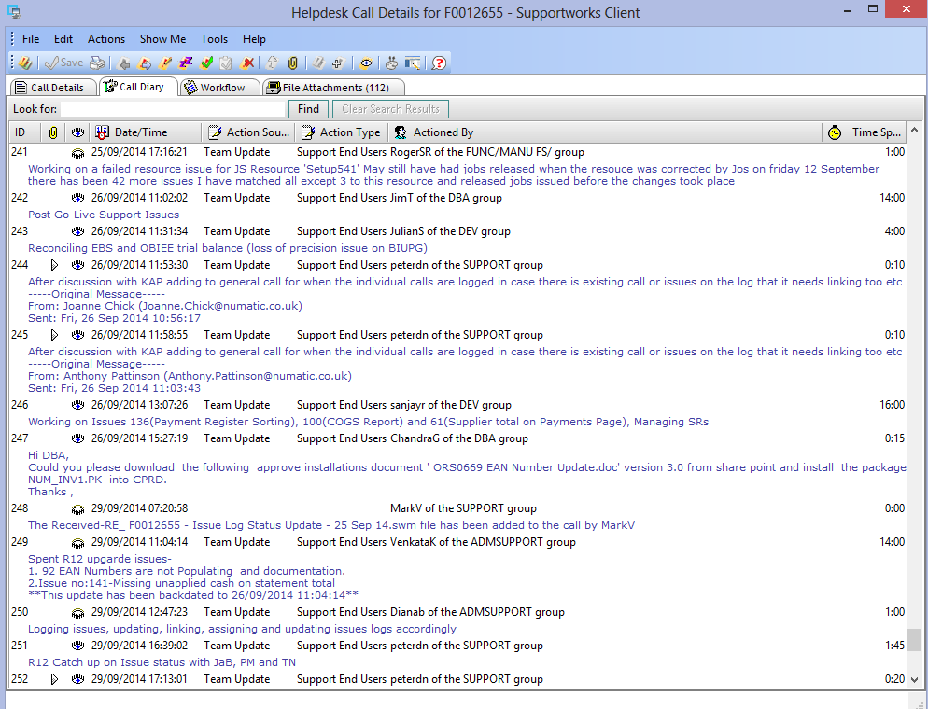

As all calls are helpdesk calls, the customer details section is required to be filled in; even though this is not applicable to many of the project related calls. As a project or upgrade of systems will not have a direct customer, it is benefiting the whole company.

Requiring users of the system to enter details such as, the customer information, will often hinder the user from logging the call. Not knowing who to put in the customer fields, does not encourage employees to log calls, leading to calls potentially not being logged or delaying the time to log a call as the employee may want to seek clarity in the customer information.

The Oracle R12 and BI Upgrade – F0012335 call is a database upgrade project and therefore has no direct customer. In this case the customer was added in as the IS Projects Manager:

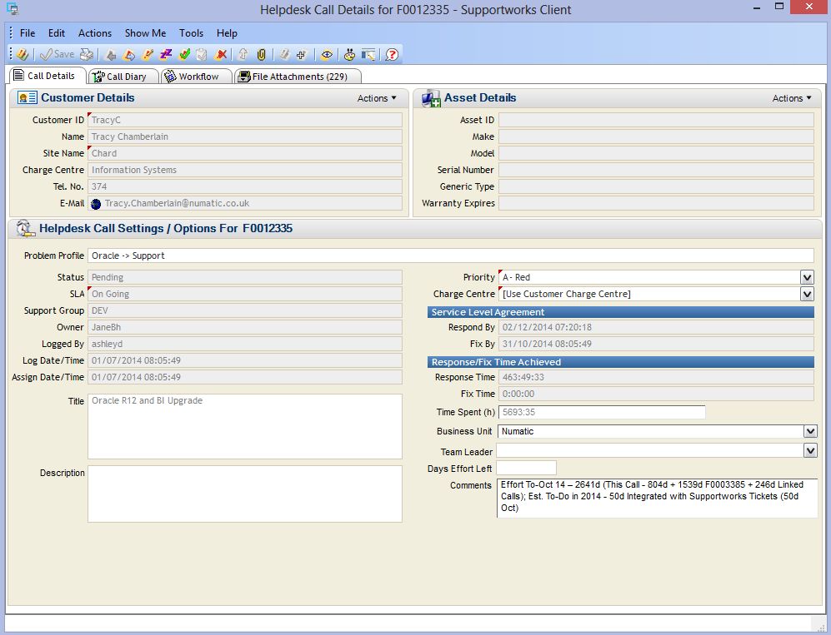

There are some calls that are indefinitely open to keep track of IS employees, for training and other various tasks. Such as the ‘IS Networking Management – F0004865’ call, used for booking time to attending meetings and training and carrying out tasks which do not fit into a particular call. These tasks are often ones that happen on a frequent basis, or are to with the general management of the team.

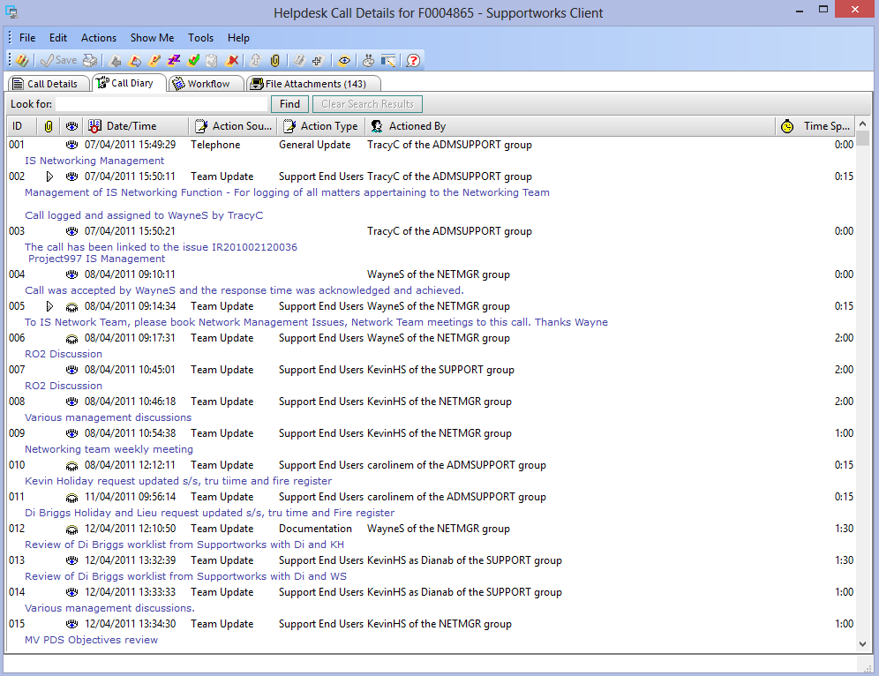

‘Helpdesk quick fixes – F0006127’, this call is open indefinatly and allows analysts to book time for general tasks, not related to one specific to a call. However this call often gets a high level of time bookings; this is mainly down to the fact it is a lot easier to book to this call, rather than creating a new call. Whilst many calls logged in this call are classed as quick fixes, logging them here means we have lost sight of two things; recurrent issues on behalf of a user, and volumes of resolved and pending calls for a department. This makes reporting on calls more complex and requires members of the admin team to read through the call to ensure none have been missed.

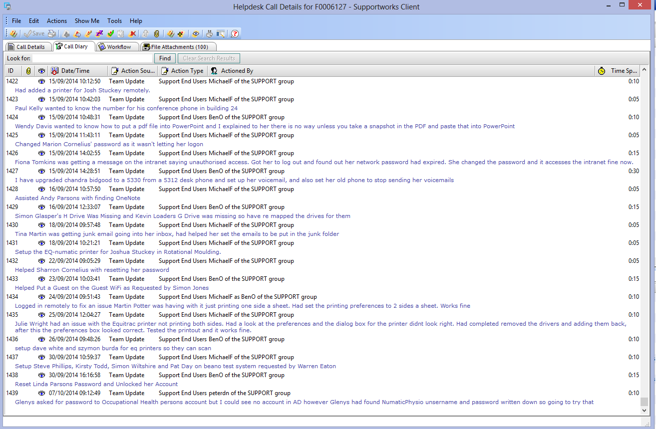



There are some calls that are open for daily tasks; allowing time to be booked for an activity which occurs on a frequent basis. Therefore calls become very large with a high quantity of updates, just to book time for completing these tasks. In a standard helpdesk system these type of tasks would not be logged in the system, however, this has been done at Numatic to allow for time bookings to be made against it. Such as the ‘Undertaking Periodic Back Up – F0003191’ call:

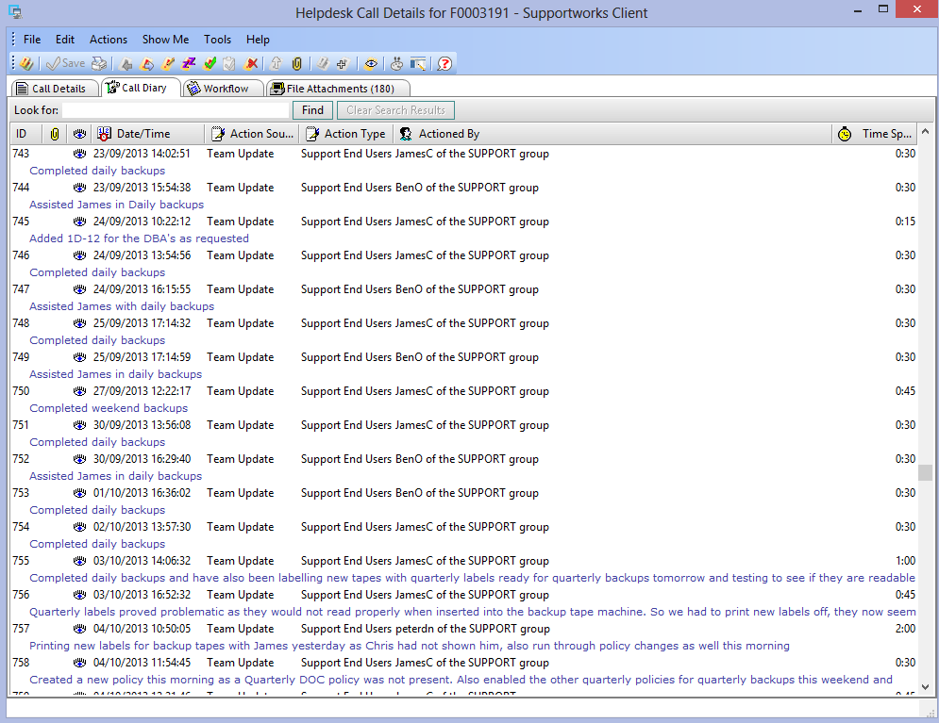

The ‘Quest TOAD Support – F0000037’ call, has been open since 2009 and is used to manage the licencing of Toad software and the management of Toad support for users. This is another example of a call that is open indefinitely and one that is primarily used once a year, when the licences require renewal.

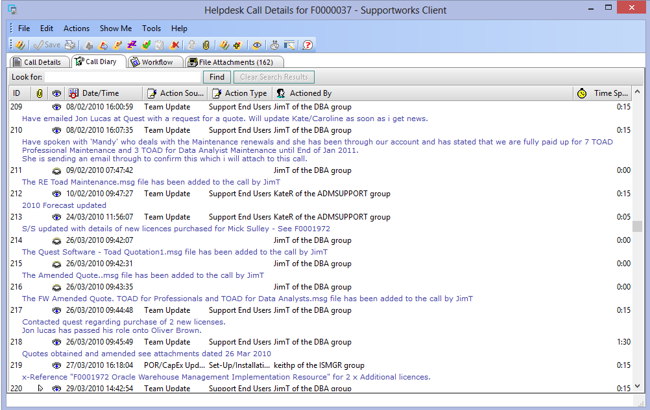

Calls are often related to an underlying issue or the overall management of devices or software, in these situations, analysts are required to link specific calls to the relevant issue. This process is often time consuming for employees and frequently problematic as the task of linking and unlinking issues is too complex. This creates annoyance and disincentives the end users to link calls to issues.

Having a large amount of issues and long issue reference numbers (issue ID), means that it is hard to find the correct issue to link the call to, it is often hard to know if there is a relevant issue without having to look through the large list of issues. Here is a list of some of the issues that a call can be linked to:

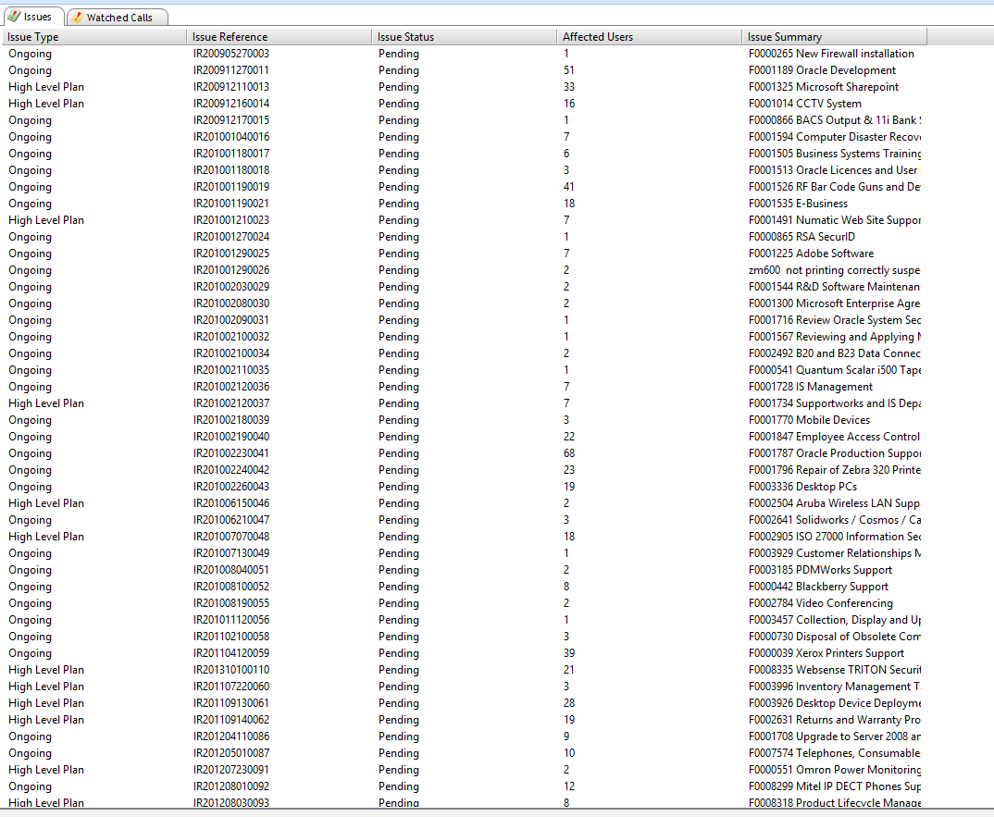

More problems are encountered when an employee tries to resolve a call that is linked to an issue. As calls cannot be resolved whilst linked to an issue, it means that users have to unlink the call from the issue, resolve the call and then link the call back to the issue again. This often annoys the end users of the system, and they get this error message after trying to resolve the call.

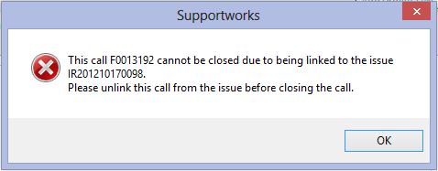

This task is made difficult as a simple requirement such as copy and paste is not available from the screen, which would allow users to be advised which calls are linked. As the codes are long it means that this task becomes a manual one, having to use pen and paper to write down the issue code and the call ID, in order to complete the process. This task is frustrating for users and provides no functionality to analysts; only assisting management with reporting of calls and issues. Therefore this does not motivate users to link calls to issues and is seen as a redundant task, which creates additional work.

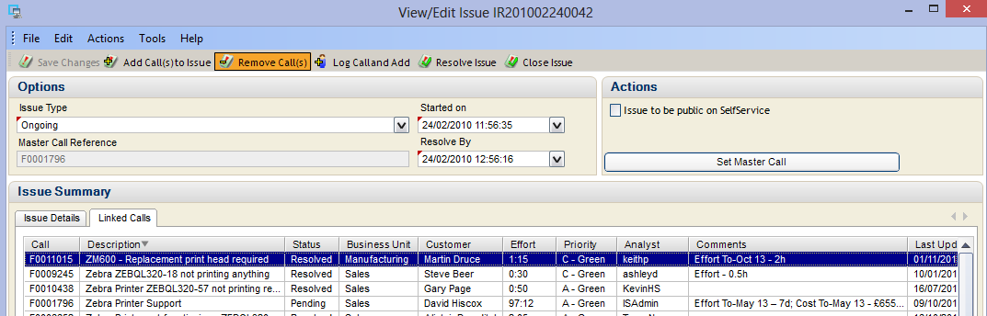

Further complications can arise from this process, by selecting ‘Resolve Issue’ instead of ‘Remove Call(s)’ the issue will be resolved. Leaving the user who resolved the issue, with all the linked calls in their own queue, which at times can be over 100 calls.

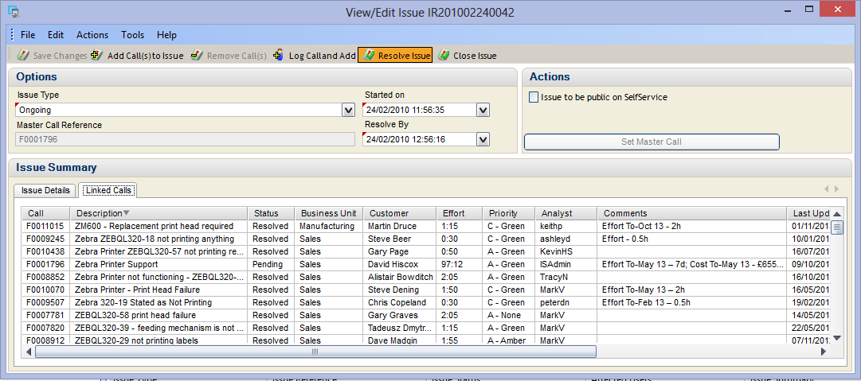

The time taken to go through every call and examine if the call needs to be re-linked and whether or not it needs to be re-assigned to another user is very high, again causing unnecessary time wasting. This often means that other employees need to get involved to help clean up the calls, such as the admin team. Mitigating this problem is also hard, with an employee accidentally resolving an issue twice within the period of a month; training users can minimise this potential problem, however, will not solve this it. This is an example of where the system’s complexity negativity impacts the use of the system and can create additional manual work.

There are also potential problems associated to time bookings; leading to inaccuracies on time booking reports. As users cannot delete an update it means that if a user accidentally books time to the wrong call then they cannot delete the update or time booked, they can only edit the update text. This often means that a user will accidently book something to wrong call and then once they have realised go back and edit the text to say booked in error. This means that when the report of time booked for the call or analyst are run, the report will be inaccurate.

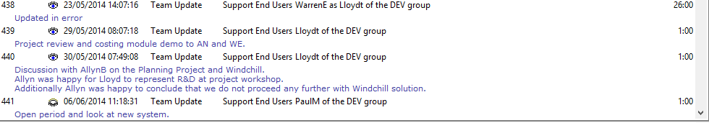

**Overall Conclusions**

From this analysis of the current system it is clear to see that whilst the system is being used to achieve many of the requirements of the IS Manager, it is not the ideal system for the job. As it has not been designed specifically for Numatic as an end user, many of the features are not used as originally intended or modified in a way to allow Numatic to use it in a way they want.

Overall many of the problems with the system steam from the fact that the system is an off the shelf generic helpdesk system, that was purchased due to price and unrealistic ideals. This has now lead to the large majority of the staff within the IS department disliking the system and find using it more of a hindrance than helpful.

This suggests that Numatic requires a new system that can be specifically customised to Numatic’s needs and business, such as better time management/booking features. This will allow the IS department to be managed more efficiently and will reduce the amount of problems that are currently seen in the system.

The new system will require emphasis on the time booking feature as well as call management. These requirements will be further investigated in the requirement elicitation phase.

**Potential Problems with New system**

Creating a new system, will allow most of the problems investigated to be minimised as the new system, will be based upon the user requirements and tailored to Numatic. However there is still the potential that there will be some problems, this is because of the way the system is used. To try and combat these issues, there will be a strong focus on user training; with user guides and a help section to the system. This will inform users on how the system should be used correctly.

# Appendix D – Questionnaire Results

# Appendix E – Questionnaire Results Analysis

The questionnaire was given to all employees in the IS department, the questionnaire aims were explained to them, and they were also informed as to why the results were required. From this sample, 11 completed questionnaires were returned. The users were given the option of completing the questionnaire anonymously if they preferred.

**Aims**

The main aim of the questionnaire is to provide some primary data from the end users of the current system. As there are over 20 users of the current system, there was not enough time or resources to interview everyone. Therefore a questionnaire was devised to get some feedback from users, it was hoped that the feedback collect via the questionnaire would back up previous findings from the observation and interviews with managers. To allow a wide selection of feedback there was a mixture of closed and open questions; giving the respondents the opportunity to give their full opinion on the current system and allow possible suggestions for future development.

**Closed Question Analysis**

To analyse the closed questions, the number of times a particular response was chosen was added up and then displayed on a bar graph to get a visual representation the results. From this the range of responses and the most commonly selected responses can be easily identified.

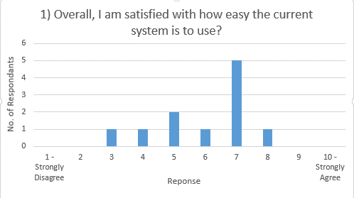**1) Overall, I am satisfied with how easy the current system is to use?**

|  |  |
| --- | --- |
| Response | Number of Respondents |
| 10 - Strongly Agree | 0 |
| 9 | 0 |
| 8 | 1 |
| 7 | 5 |
| 6 | 1 |
| 5 | 2 |
| 4 | 1 |
| 3 | 1 |
| 2 | 0 |
| 1 - Strongly Disagree | 0 |

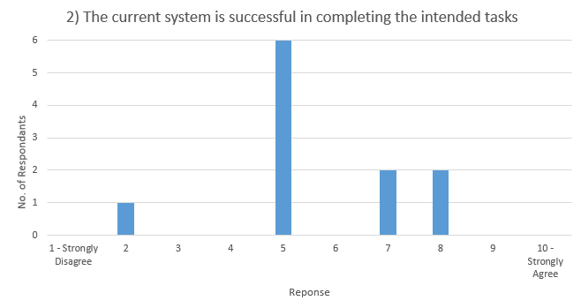**2) The current system is successful in completing the intended tasks**

|  |  |
| --- | --- |
| Response | Number of Respondents |
| 10 - Strongly Agree | 0 |
| 9 | 0 |
| 8 | 2 |
| 7 | 2 |
| 6 | 0 |
| 5 | 6 |
| 4 | 0 |
| 3 | 0 |
| 2 | 1 |
| 1 - Strongly Disagree | 0 |

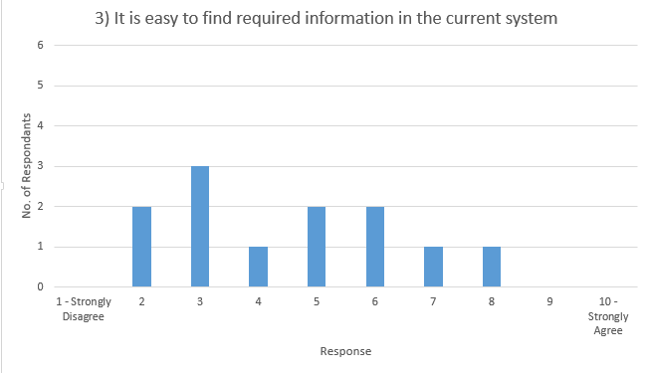**3) It is easy to find required information in the current system**

|  |  |
| --- | --- |
| Response | Number of Respondents |
| 10 - Strongly Agree | 0 |
| 9 | 0 |
| 8 | 1 |
| 7 | 1 |
| 6 | 2 |
| 5 | 2 |
| 4 | 1 |
| 3 | 3 |
| 2 | 2 |
| 1 - Strongly Disagree | 0 |

**Open Question Analysis**

To analyse the open questions, all the responses have been categorised into groups, these groups are the headings of each column. Any further comments were then added into the table in the rows of the appropriate group. This allows any easier way to view all comments and highlight any key responses, it all shows any themes or common answers to the question.

**4) What does the current system do well?**

|  |  |  |  |
| --- | --- | --- | --- |
| Time Recording | Call Management | User Interaction | Nothing |
| Time Keeping | Displays priorities and fix times etc. | Lets colleagues know what needs doing and what has been done. | Left blank |
| Time reporting – weekly, monthly | Central point for issues. | Integrates well with our user base. |  |
| Good way to see how much time is spent [on a call] and what issues throughout the day/week/month | Provides historic information on issues/calls. |  |  |
|  | Ability to log calls against problem profiles. |  |  |
|  | Good for management of problem solving. |  |  |

**5) What improvements would you make to the current system?**

|  |  |  |  |
| --- | --- | --- | --- |
| Data Management | Reliability | Design | System use with the business/ Functionality |
| Better search functionality, the free text search isn’t the best when searching for a call. | Not crash every day. | Fewer click throughs. | System is being used for more than it is designed for. |
| Improve search capability – context search. | Stability – current system crashes a lot. | Better navigation and fewer icons. | Workflow driven problem determination and resolution. |
| Better management of issues. | Stop all the errors. I.e. Constantly crashing. | More user friendly – too cluttered. | Re-evaluation of how calls are assigned. |
| Easier to store information and gain access to it. | Improve reliability. | Create FAQ | Option for public/ private updates. |
| Issues being stored alphabetically. |  | Improve functionality – linking and unlinking calls. | Users to track their own f number (call) |
| The search facility is not always so successful – therefore a better search function. |  |  |  |

**6) What would you say are the most important features of a new helpdesk system for Numatic?**

|  |  |  |  |
| --- | --- | --- | --- |
| Call Management | Time Recording | Design | Functionality / System use with the business |
| Ability to record and track issues. | Time keeping and booking. | User friendly. | Used properly and updated by everyone. |
| A workload sharing system. | Time recording. | Simple and intuitive – avoid large user guide | User to monitor [call] progress. |
| Keeping track of customer issues. |  | Intuitive. | Merging duplicates. |
| Solution finding. |  |  | Better way of documenting solutions. |
| Suggesting solution before helpdesk call submitted. |  |  |  |
| Managing issues and being able to search easier for previous similar issues. |  |  |  |
| Searching of calls. |  |  |  |
| Historic data search and logging accurate information against issues. |  |  |  |

**7) Do you have any other comments or suggestions about the current or new system?**

Keep it simple.  
Current system is overloaded with junk.

**Overall Conclusions**

# Appendix F – Interview Transcripts

**Interviews with Managers:**

To get a better understanding of what each section of the IS department require from the system, interviews have been carried out, these interviews involved a very open discussion with what they felt is the most important features of a new helpdesk system. Due to the large amount of IS staff, the interviews have only been done with managers. Only open questions have been used in these interviews, this is to allow me to collect as much information as possible.

**What is good about the current system?**

**DBA Manager:**

* Allows the team to communicate any updates or problems, as one of the team might be on the late shift and can make an update; notifying whoever might be on the early shift to do something early the next day. Which means all updates are stored in a known location and time is saved not having to look through emails and other means of communication.

**IS Development Manager:**

* There isn’t anything that particularly stands out as a good feature for me or my team, this system is more focussed for issues and calls used in the networking team.

**IS Networking Manager:**

* There is a good way of easily logging calls as soon as someone rings or emails the helpdesk. It allows us to keep track of calls and I can ensure that a call has been assigned to member of the networking team, meaning no calls should be missed or forgotten about.

**IS Projects and Admin Manager:**

* The watched calls feature is very helpful, allowing quick access to calls used on a regular basis – this feature should be required in the new system.

**What are the biggest pain points or the causes of problems in the current system?**

**DBA Manager:**

* The linking call process of linking a call to a particular issue is very complicated and a long winded process (having to link, unlink, then link again). Another problem with the process is that the issue name/title is not shown during the process, only the issue number (which has no meaning).

**IS Development Manager**

* Using the system as a helpdesk and to manage time does not work well. Using the system for time management, means that often the calls get updated with purely time booking updates, such as what was done that week. This makes finding proper updates that are relevant hard and adds unnecessary information to the calls.

**IS Networking Manager:**

* Ongoing calls such as licence renewals each year are currently just placed on hold each year – this shouldn’t be the case – they need to be dealt with in a different way. It just means that the call cannot be closed or resolved during the mean time.
* Calls should be closed and should not just be resolved.
* Would like to have calls separated or a way of identifying the call type/ class, such as, day to day calls/ license management/ projects.

**IS Projects and Admin Manager**

* The current system crashes randomly and especially after a period of inactivity, which causes unnecessary pain and time wasting.

**What features would you most like to see in the new system?**

**DBA Manager:**

* A way of differentiate between calls (tickets) would be very helpful. At the moment a member of my team may have 4 red calls sat in his queue, all of which have been accepted; they are all now in the pending state. However, one may be awaiting the user’s response and another may be pending development. There is no way of distinguishing between these without having to look back through the call to find out. Further options rather than pending need to be implemented.
* Different levels of priority implemented rather than just Red, amber and green priorities. As some calls may be labelled as red but are not critical or stopping the business from operating. It would be helpful to show the type of call, i.e. Incident or service request.

**IS Development Manager:**

* Would like the latest updates in a call to be at the top of the rather than having to scroll to the bottom. As it wastes time and often the oldest updates are the least relevant.

**IS Projects and Admin Manager**

* An unaccepted call reminder for analysts would be helpful, maybe a pop up or some sort of message displayed in the system.
* The ability to personalise the view would make the new system more use friendly to use.
* An easy way to merge calls – i.e. if multiple calls have been logged for the same problem.
* The most recent update in the call should appear first, when opening the call rather than having to scroll down to the bottom.
* Free text search – This would be helpful to search for calls when you do not know the exact name or the ‘F number’ (call ID).
* I would like to be able to see the time spent per month in calls rather than just a total time spent, so the admin team can compare times each month.

**What features of the old system would you like to remain in the new system?**

**DBA Manager:**

* All the standard features of the helpdesk software (logging calls, updating calls, resolving calls etc.), although, more the system should be more simplistic. The system is over complicated at the moment.

**IS Development Manager:**

* The ability to assign calls to different analysts needs to remain in the system.

**IS Networking Manager:**

* An asset management section like there is currently in the system would be helpful. However, it would only be good and beneficial if we used it properly and kept the system up to date, which does not happen at the moment.

**IS Projects and Admin Manager**

* As previously mentioned the watch calls list should remain in the system.

**Any other comments?**

* Improved reporting, currently reports only show in minutes and not in days; meaning there is a manual task of dividing these figures into days, which is more time consuming.

# Appendix G – Evaluation of Software Development Methodologies

**Possible Software development Methodologies:**

A software development methodology is a framework used to structure and manage the overall development of a software development project and the final system or solution. My project is to create a helpdesk system for Numatic, following a development methodology will ensure all the required parts of the lifecycle are complete and will assist in the management of the project. Whilst there are many different methodologies, below I have investigated and discussed various different methods, this will allow me to select the most appropriate and beneficial method for this project.

**Waterfall Development:**

This is one of the most common software development methodologies used when developing software. The Waterfall model stipulates that each stage is required and must be followed in sequence. Additionally each stage is completed by either validation, verification or testing to make sure the stage has been completed successfully and requires an agreement to sign off on a phase and move onto the next stage.

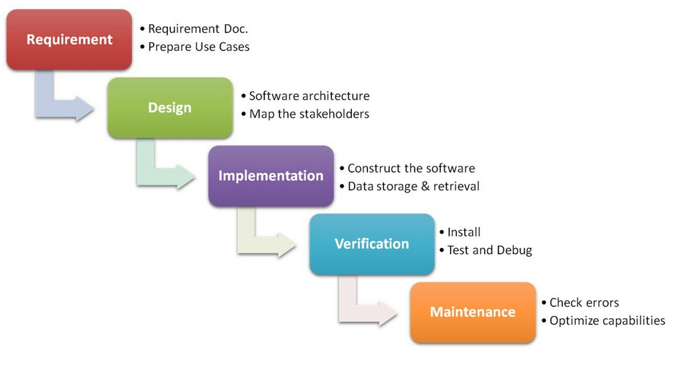

The main emphasis of this methodology is the emphasis that is placed on planning, strict deadlines and short time span; in those instances the Waterfall model works well to minimise process overhead. Following the Waterfall model yields a well-structured and controlled approach, with tight control over the whole project down to the extensive documentation. These standards ensure nothing is missing from the specifications before progressing from one stage onto the next stage and allows the client to sign off each stage. Progress is reviewed at the end of each stage thus helping to achieve specified dates in the project plan, the emphasis on documentation and design before building the system helps minimize time and effort wastage.

When using the Waterfall model, going back to any previous stage should be avoided at all costs, therefore it is most important to correctly identify all requirements up front. All system development is completed in a single stage, so the customer will not see many signs of progress until nearing the end of the project, thus projects should not be time critical.

The main disadvantage with this methodology is that the requirements have to be very well defined and the client has to be sure they will not want to add additional requirements after the requirement stage has been completed. If this happens it will have a knock on effect throughout the project, meaning a delay and this methodology does not have a way of controlling this scenario.

There are some advantages of using this methodology, the model is very simple and easy to use, allowing inexperienced staff and managers to manage a project effectively. Having defined stages allows the progress of the project to be measured and the strict controls over stages ensure the products from each stage are of high quality and that the client is happy with them.

In projects where the requirements are formally set out and will not change during the project, this methodology is most suitable. Also projects that are not time critical, this is due to the fact that as there is only one iteration of the lifecycle if it is late then there will be no system in place.

**Agile Approach**

Unlike the Waterfall approach where the requirements are fully defined and signed off before development begins, the iterative approach begins by specifying and developing a certain part of the software/solution. At the end of the iteration the software is reviewed and helps to identify any further requirements. This is then repeated until the client agree they are happy, there are many different agile practises, such as, extreme programming and scrum.

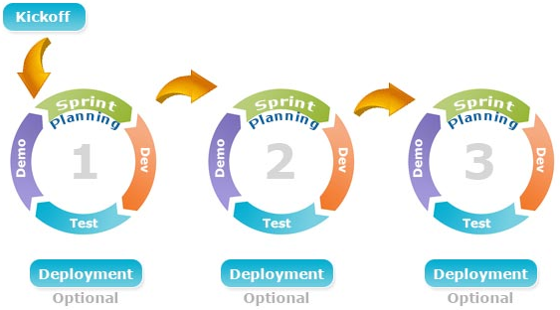

The rapidity of development is one of main advantages of choosing an agile approach, having a minimum level of a working system quickly is often much preferable than having to wait much longer for a complete system. The high levels of communication and less rigid approach allows for much more freedom and consequently leads to an end product that the end users want.

However, there are some disadvantages of agile, heavy client participation is required which can be costly and time consuming. There is also a large possibility of scope and cost to increase during the project as new requirements emerge and evolve.

Agile is best implemented with projects that involve new systems, where the requirements are not set in stone and may need changing, changes can be changed quickly due to the iteration process of development.

**Prototyping Approach**

Prototyping is a useful software development methodology allowing, prototypes to be developed for a particular functionality or parts of the system. Prototypes are built to allow the client to look at a system which has the current requirements, this allows them to get a feel of the system and to help with requirement elicitation.

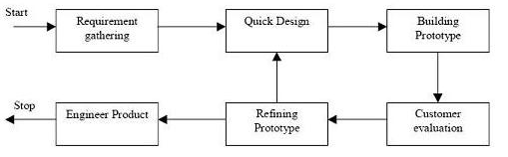

The main advantage of this methodology is the client and user interaction during the project, meaning they will have a clear understanding of the system being developed; enabling feedback from the client to be quick. This high level of interaction increases the quality of the end product and allows for the developers to also ensure they fully understand the requirements and missing functionality can be easily identified.

There also disadvantages of this methodology, such as, there being too much dependency on prototypes and the prototypes being used in the development of the actual system even if it is not appropriate. The possibility of confusing the end users between prototypes and the end product may also happen.

Prototyping is most successful when the project requires a high level of end user interaction, it also allows the users and client to be continually working with the system as it is developed. This is normally best for large projects or projects with complex requirements.

**Conclusion of Development Methodologies:**

After investigating many different methods of software development, I have concluded the agile model is the most relevant to my project. Whilst all software development methods have their own strengths and weaknesses, the agile approach fits in well with the project. Separating the project into stages allows the client to quickly get a system and can see the product developing, perhaps more importantly the requirements can also be refined and developed throughout the project ensuring the client will be happy with the end product which should also increase the quality of the system.

References:

<http://istqbexamcertification.com/what-is-waterfall-model-advantages-disadvantages-and-when-to-use-it/>

<http://istqbexamcertification.com/what-is-prototype-model-advantages-disadvantages-and-when-to-use-it/>

<http://www.tutorialspoint.com/sdlc/sdlc_software_prototyping.htm>

<http://www.iotap.com/blog/entryid/124/advantages-disadvantage-of-prototyping-process-model>

<http://www.allaboutagile.com/disadvantages-of-agile-development/>

<https://www.cms.gov/research-statistics-data-and-systems/cms-information-technology/xlc/downloads/selectingdevelopmentapproach.pdf>

# Appendix H - Evaluation of Development Technologies

**Introduction**

The initial scope of this project and discussions with Numatic about the type of system they wanted, allowed the client to develop basic requirements and to decide on the technologies that will be used in development.

There are of course many different types of system that could be developed; from desktop applications, web applications and phone/table applications. Currently SupportWorks; a desktop application, is used on site at Numatic. They have stated that they would be open to any type of system providing there is a strong justification and benefit provided to the company upon choosing that method. They are also looking to reduce the cost as much as possible, currently Numatic is having to pay for licencing the current system but also maintenance fees of the SupportWorks application.

**Web vs desktop application**

Both type of application would require the use of a server within the company; due to the database storing the data needed to be accessed by many people. If a web app was used, this would be accessible to employee, by the use of localhost; reducing the storage of an application on an individual machine. However this may become problematic if there was an incident involving the server(s) being down, although it is noted that the current is also reliant upon the server and would also not work in this situation.

After discussions with the client they would like to move to a web application in line with other systems used at Numatic including the Product Lifecycle Management Portal (PLM Portal) and the complex intranet that serves the company. This also reduces the network team’s job of having to install an application onto the user’s computers and allows the application to be used from any computer as nothing needs to be installed.

**Possible Technologies**

The front end will be developed with HTML and CSS, to create a simple and easy to use interface. There are different options of technologies to develop web applications, the most common being client side language of PHP with a MySQL database or ASP.NET and MSSQL. These have been further investigated below:

When choosing a client side scripting language many aspects were taken into account – as seen below, this was then present to the client for discussion allowing an informed decision to be made by Numatic.

|  |  |  |
| --- | --- | --- |
|  | PHP | ASP.NET |
| Cost | Completely free | Cost associated with a development environment – Visual Studio |
| Performance | PHP is often regarded as high performance, especially when utilising the use of LAMP – Linux, Apache, MySQL and PHP; which has been optimised for performance. | ASP.NET also performs well with MSSQL |
| Support | PHP is free and very popular, there is a large support network and forums dedicated to PHP | Not as widely used or has such a large support community. |
| Popularity of language | PHP is ranked number 6 of the most popular languages- as seen in fig.1 | Not included on the list – up to top 20 most popular |
| Ease of learning | PHP is easy to pick up, there are also many tutorials and tools to learn PHP online | ASP.NET is considered more complex and harder to learn than PHP. |

From these comparisons it is clear to see that PHP holds many benefits to the client mainly the fact it is completely free, it can perform to all of Numatic’s requirements and has a wide range of support online. After discussions with the client and the developers at Numatic the PLM portal has also been developed in PHP, therefore it makes sense for the client to be consistent with development technologies. This means that once the system has been transferred to the client there will be suitable support to maintain the system and possibly develop the system over time as the developers at Numatic are familiar with PHP.

Fig. 1 – TIOBE Index of popularity

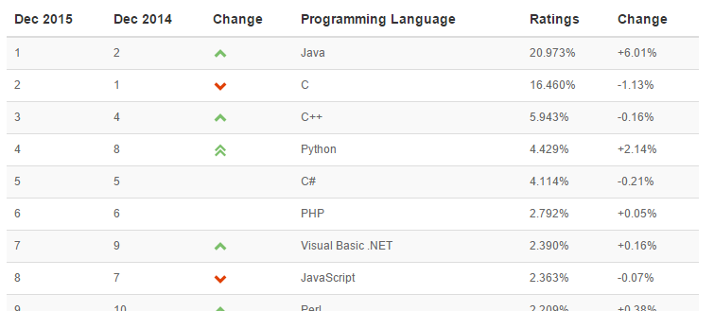

**Security**

The system will be hosted on Numatic’s internal server and while security will still need to be thought about in detail, it will not have to meet the standard required to be hosted online. Methods such as authentication and basic encryption will be deployed, to stop unauthorised people from accessing information.

One benefit of going with a web application is the ability of putting it online, to allow employees who are off-site to access the helpdesk. This scenario is currently out of scope for this project; although this could be a possible development in the future. If this development was carried out, then extra security measures would need to be added and carrying out penetration testing would allow any vulnerabilities to be exposed.

# Appendix I – ITIL Investigation

The client has expressed interest in the new system following ITIL principles to allow the IS department to eventually move to an ITIL framework approach of working. Therefore the ITIL practises have been investigated, allowing the requirements of the new system to reflect this and discussions with the client.

**ITIL Introduction**

Information Technology Infrastructure Library (ITIL) is a defined set of practises for IT Service Management (ITSM). ITIL was established in the early 1990s when there was a growing need for IT service management, which led to a series of books that documented the approach being developed, since then it has been updated and is now on the third version of ITIL.

ITIL is very well recognised and is successful, often down to the selection of best practises

The core guidance is on the following topics:

* Service strategy – Guidance is given on the principles that underlie service management, which allows for the organisations to set objectives relating to the performance
* Service design – Plans to create and change services and service management processes.
* Service transition – Manage the transactions of a new or changed services.
* Service operation – This gives guidance regarding the day to day operations of services and service management processes.
* Continual service improvement – This is the activities that are included in the overall service lifecycle.

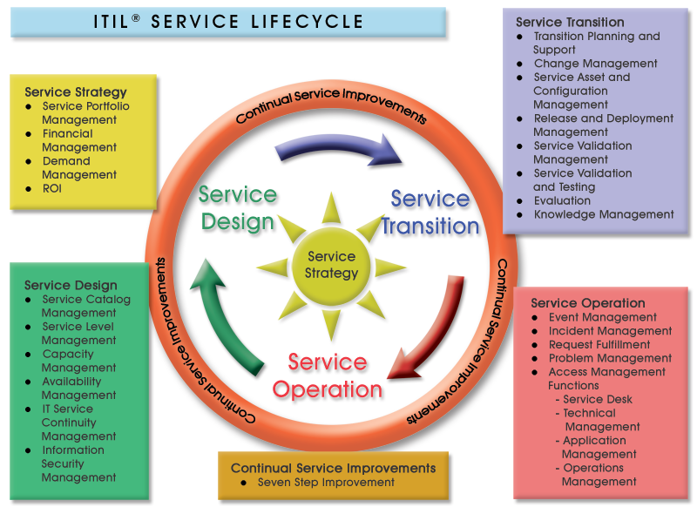

**Service Operation**

Service operation is a key area of the ITIL practises, where there is a high business value and customers in particular can see value. This section focusses on the service desk, technical management, IT operations management and application management.

This investigation is primarily looking at the service desk, to allow the new system for Numatic to be developed in a way that conforms to the principles. The service desk will be…. although, it is noted that in order for the service desk to be successful the staff using it, must provide a good service, provide a timely and professional service. Meaning business can continue to run in an effective manner, in order to allow this staff will need appropriate training as part of the implementation phase of the project.

There are many different processes that should be included in a service desk, these are:

* Event Management – The monitoring of events through IT infrastructure.
* Incident Management – Looking at restoring a disruption to services to users as quickly as possible.
* Problem Management – This is focused on root cause analysis of events and incidents, to allow causes to be resolved.
* Request Fulfilment – The process of managing customer’s requests.
* Access Management – The process of granting users permission to certain services.

These have been further investigated below to help ensure that all information is collected prior to the design stage of development to ensure it can be discussed during requirement elicitation of the system.

Incident Management:

This is perhaps the most common part of a service desk and will be used frequently at Numatic, with over 400 PCs on-site and the manufacturing that is heavily reliant upon IT, there are many end users that many report incidents to the IS Helpdesk- primarily by phone or email. In incident is classed as ‘an unplanned interruption to an IT service’ and the main aim is to restore normal operation as soon as possible, to reduce disruption.

Some examples of incidents include:

* Printer or hardware faults,
* Systems down,
* Errors occurring in applications,
* Disk space full

Principles of incident management:

* Timescales - Every incident must have an agreed timescale, based on priority of incident and SLAs. These should be automatic.
* Incident Models - Used to treat recurring incidents with a standard procedure.
* Status tracking - All incidents should be tracked throughout their lifecycle. Statuses of incidents will be; open, in progress, resolved, closed.

Relevant information must be included when logging incidents, this might include:

|  |  |
| --- | --- |
| Unique ID |  |
| Categorisation | Ensures the type of incident is recorded |
| Urgency | Urgency and impact can be used together to allow a priority of an incident to be determined. Example coding below: |
| Impact |
| Prioritisation |
| Date/time recorded |  |
| Name of person recording incident |  |
| End user details |  |
| Description of symptoms |  |
| Incident status | open, in progress, resolved, closed |
| Allocated analyst or support group |  |
| Related problem/ known error |  |
| Activities undertaken to resolve incident |  |
| Resolution date and time |  |
| Closed category |  |
| Closure date and time |  |

Request Fulfilment:

A service request is a request made to the IT department by users, these are usually small and frequent requests. Examples of these requests include:

* Installing additional software
* Request to change password
* Request for workstation move
* Request for information

Relevant information must be included when logging requests, this might include:

|  |  |
| --- | --- |
| Unique ID |  |
| Categorisation | Categorise the request by the activity that is being undertaken. E.g. Password reset, desktop installation. |
| Urgency | Urgency and impact can be used together to allow a priority of an incident to be determined. Example coding below: |
| Impact |
| Prioritisation |
| Date/time recorded |  |
| Name of person recording incident |  |
| End user details |  |
| Description of request |  |
| Request authorisation | Ensure the request is authorised before it is undertaken. |
| Request status |  |
| Allocated analyst or support group |  |
| Fulfilment date and time |  |
| Closure date and time |  |

Problem Management:

The purpose of problem management is to manage all problems leading to identifying the underlying errors in the IT infasture, once the underlying problems are fixed it is hoped to reduce the number of related incidents. These technical issues can exist without nessicarily effecting the users, examples of these problems include:

* Erratic disk space
* Slow network
* Applications crashing intermittently

These problems are different from incidents and will usually be assinged to more senior members of the support team, that are 2nd/ 3rd line support.

Relevant information must be included when logging problems, this might include:

|  |  |
| --- | --- |
| Unique ID |  |
| User Details |  |
| Service details |  |
| Equipment details |  |
| Prioritisation |  |
| Urgency |  |
| Impact |  |
| Name of person recording incident |  |
| Date/time recorded |  |
| Categorisation | Problems will be categorised in the same way as incidents. |
| Incident description |  |
| Incident record numbers/ cross references |  |
| Diagnostic and attempted recovery actions taken. |  |
| Allocated analyst or support group |  |
| Resolved date and time |  |
| Closure date and time |  |

Access Management:

The process of granting the users the permissions to a particular service providing they have adequate level of access. Examples of this include:

* Removing / granting access when users change roles or jobs
* Giving a particular user or user group permissions to a service

Requests for changes in access will be primarily done through a service request via the service desk.

Event Management:

Event management is about knowing the state of the IT infrastructure, which detects and alerts if there are any deviations from expected behaviour. Examples of these events, which may need investigating are:

* Failed login with incorrect password
* Completion time of transactions taking unacceptable time
* Server memory approaching highest acceptable performance level

These events will often be logged and notifications will alert staff members if required, these events should be logged along with any additional actions taken in an event management tool. In some instances an event may be handled in an incident, problem or service request; these will be logged through the system.

**Current System**

As explained in the analysis of the current system document, Numatic’s current system has no method of identifying the type of ticket, meaning all tickets are classed as incidents. This often becomes problematic due to the number of tickets open, many of these are not actually incidents and are more often service requests and problems. This means there is no way of narrowing down the view, to only see incidents or other types of tickets, it can also confuse analysts with the most important tasks that are required to be done. If an ITIL approach was taken many of these problems see with the current system would be reduced and it would also allow other parts of ITIL to be followed, thus improving the efficiency of the department.

**New System**

Numatic would like their whole IS department to follow the ITIL methodology, whilst much of the ITIL practises cannot be solved by just implementing a new system, it is hoped a new system will help pave the way for the practises to put in place. Many of the ITIL practises will take a long time to be implemented throughout the department and may mean a change in procedures and way of working.

# Appendix J – Off the Shelf Software Solutions

**Off the shelf software solutions**

There are many off the shelf helpdesk and servicedesk systems available for use within businesses like Numatic. Currently Numatic are using an off the shelf solution – SupportWorks ITHD system, which has been in place at Numatic for many years now, Numatic now require a new software to replace their current system. They have

**Comparison of different software available:**

Below a comparison of different helpdesk systems has been undertaken to find the best solution for Numatic.

|  |  |  |  |
| --- | --- | --- | --- |
|  | SupportWorks | Cherwell Service Management Tool | Richmond Service Desk |
| Functionality | Integrated knowledge base,  Email integration,  ITIL processes,  Asset management,  Email integration,  SaaS based, | Self-service portal,  ITIL processes,  Complex workflows,  Integration with other systems,  Knowledge base, | Customer service portal,  Complex dashboard,  Export to Excel function,  Post resolution survey,  ITIL processes |
| Cost | £ 9,500 plus yearly licence and maintenance fees | £74,360 plus yearly licence and maintenance fees | £25,200 plus yearly licence and maintenance fees |
| Application type | Desktop application | Web application and mobile app | Web applications |

From the table above, the SupportWorks system is best matched to the business needs of Numatic, this software is an updated and newer version of the currently used system. Simply upgrading has many advantages including, ongoing support with the system and already being aware of how the system works. However, this could also be a very risky option, many of the problems that exist in the current system, may still be prevalent in the upgraded version, meaning the client will be paying more money but still may not be happy with the system.

**Bespoke vs off the shelf systems**

|  |  |  |
| --- | --- | --- |
|  | Off the shelf | Bespoke |
| Cost | There are many costs associated with an off the shelf system, there is the one of cost associated with the purchasing of the software. As well as more regular costs required, such as licencing and maintenance. | Normally the cost of bespoke systems are very high, due to not only the cost of development but also investigation and requirement elicitation and the rest of the software development lifecycle. However, in this instance bespoke development will be free due to being part of a university project and therefore would be an ideal opportunity to develop a system to the client’s exact requirements. However, there will be a slight cost incurred in deploying the system and training users. |
| Future Development | Many of the off the shelf systems are continually developing throughout updates and newer versions of the software, however, these updates add additional costs to the business and require installation. There is also limited scope for customisations to the software, which has been done with SupportWorks used at the moment. These customisations allow the generic system to be slightly tailored to Numatic. | After deployment of the bespoke system, Numatic will have full control over the system and this means that any additional requirements and functionality to the system can be added if required. Numatic have in house developers that could do this if required. |
| Functionality | The systems investigated had a wide selection of functionality available, including additional parts of the system, such as, an asset management system. Whilst these additional functionality is helpful to have, it may not all be required for use within Numatic. | There will be less functionality in the bespoke software compared to that of the off the shelf systems. The functionality would be limited to the initial requirements of the system, however, this reduces the complexity of the system, making it easier to use. It also means that there is not a lot of unused parts of the system. |
| Fit into the business needs | The system will be not be tailored to Numatic’s way of working and is a generic system. This means that the business needs to work around the system which often causes problems or additional work for the department and is not ideal. | A bespoke system will fit into Numatic’s way of working and business needs. Before development will start, analysis of requirements will be done allowing for the system to be developed exactly how it is wanted. |
| Support | Off the shelf systems, have the advantage of being used by many different customers meaning that finding a major bug in the system is unlikely. Most of the systems have dedicated support methods, such as, 24/7 support for major issues, bug reporting and online forums offering support. | Bespoke systems do not provide that level of support, however, once the system is handed over to Numatic, the system will be their own and the developers at Numatic will have the knowledge to be able to go through the code should it be required. As a bespoke system will most likely be a lot simpler, it will also mean that debugging any issues should not be too complicated. |

**Conclusions**

From the above research and discussions with the client about a solution to a helpdesk system, they felt that it is a great opportunity to develop a bespoke helpdesk system to meet their exact requirements. As cost was a main factor in choosing a solution, it meant a huge saving and having the added benefits that bespoke development will bring; tailoring a system to Numatic, options for future development and all required functionality.

# Appendix K – GUI / Front-End Design Document

**Meeting with Client**

A meeting was held with the client to discuss the GUI designs of the front end of the system, during the meeting overall design possibilities were discussed and the design specifications were developed.

**Design Specifications**

This design specification was developed throughout the meeting with the client, allowing the client to specify what constraints they would like to apply to the system. These specifications are mainly targeted at providing a consistent and easy to use interface.

* Contain Numatic’s logo
* Consistent page designs with one overall template for the system
* Font Arial and size 12
* Developed for use on a 24inch monitor
* Contain a help button/ page
* Provide on screen help where necessary
* Ensure cross browser compatibility
* Easy to navigate

**Paper Based Designs**

Initially paper based designs were developed to allow the Client as brief insight into how the final system may operate and look like. These designs were then developed into digital designs and later prototyped using HTML/CSS. The original designs are shown below:

Main theme of helpdesk:

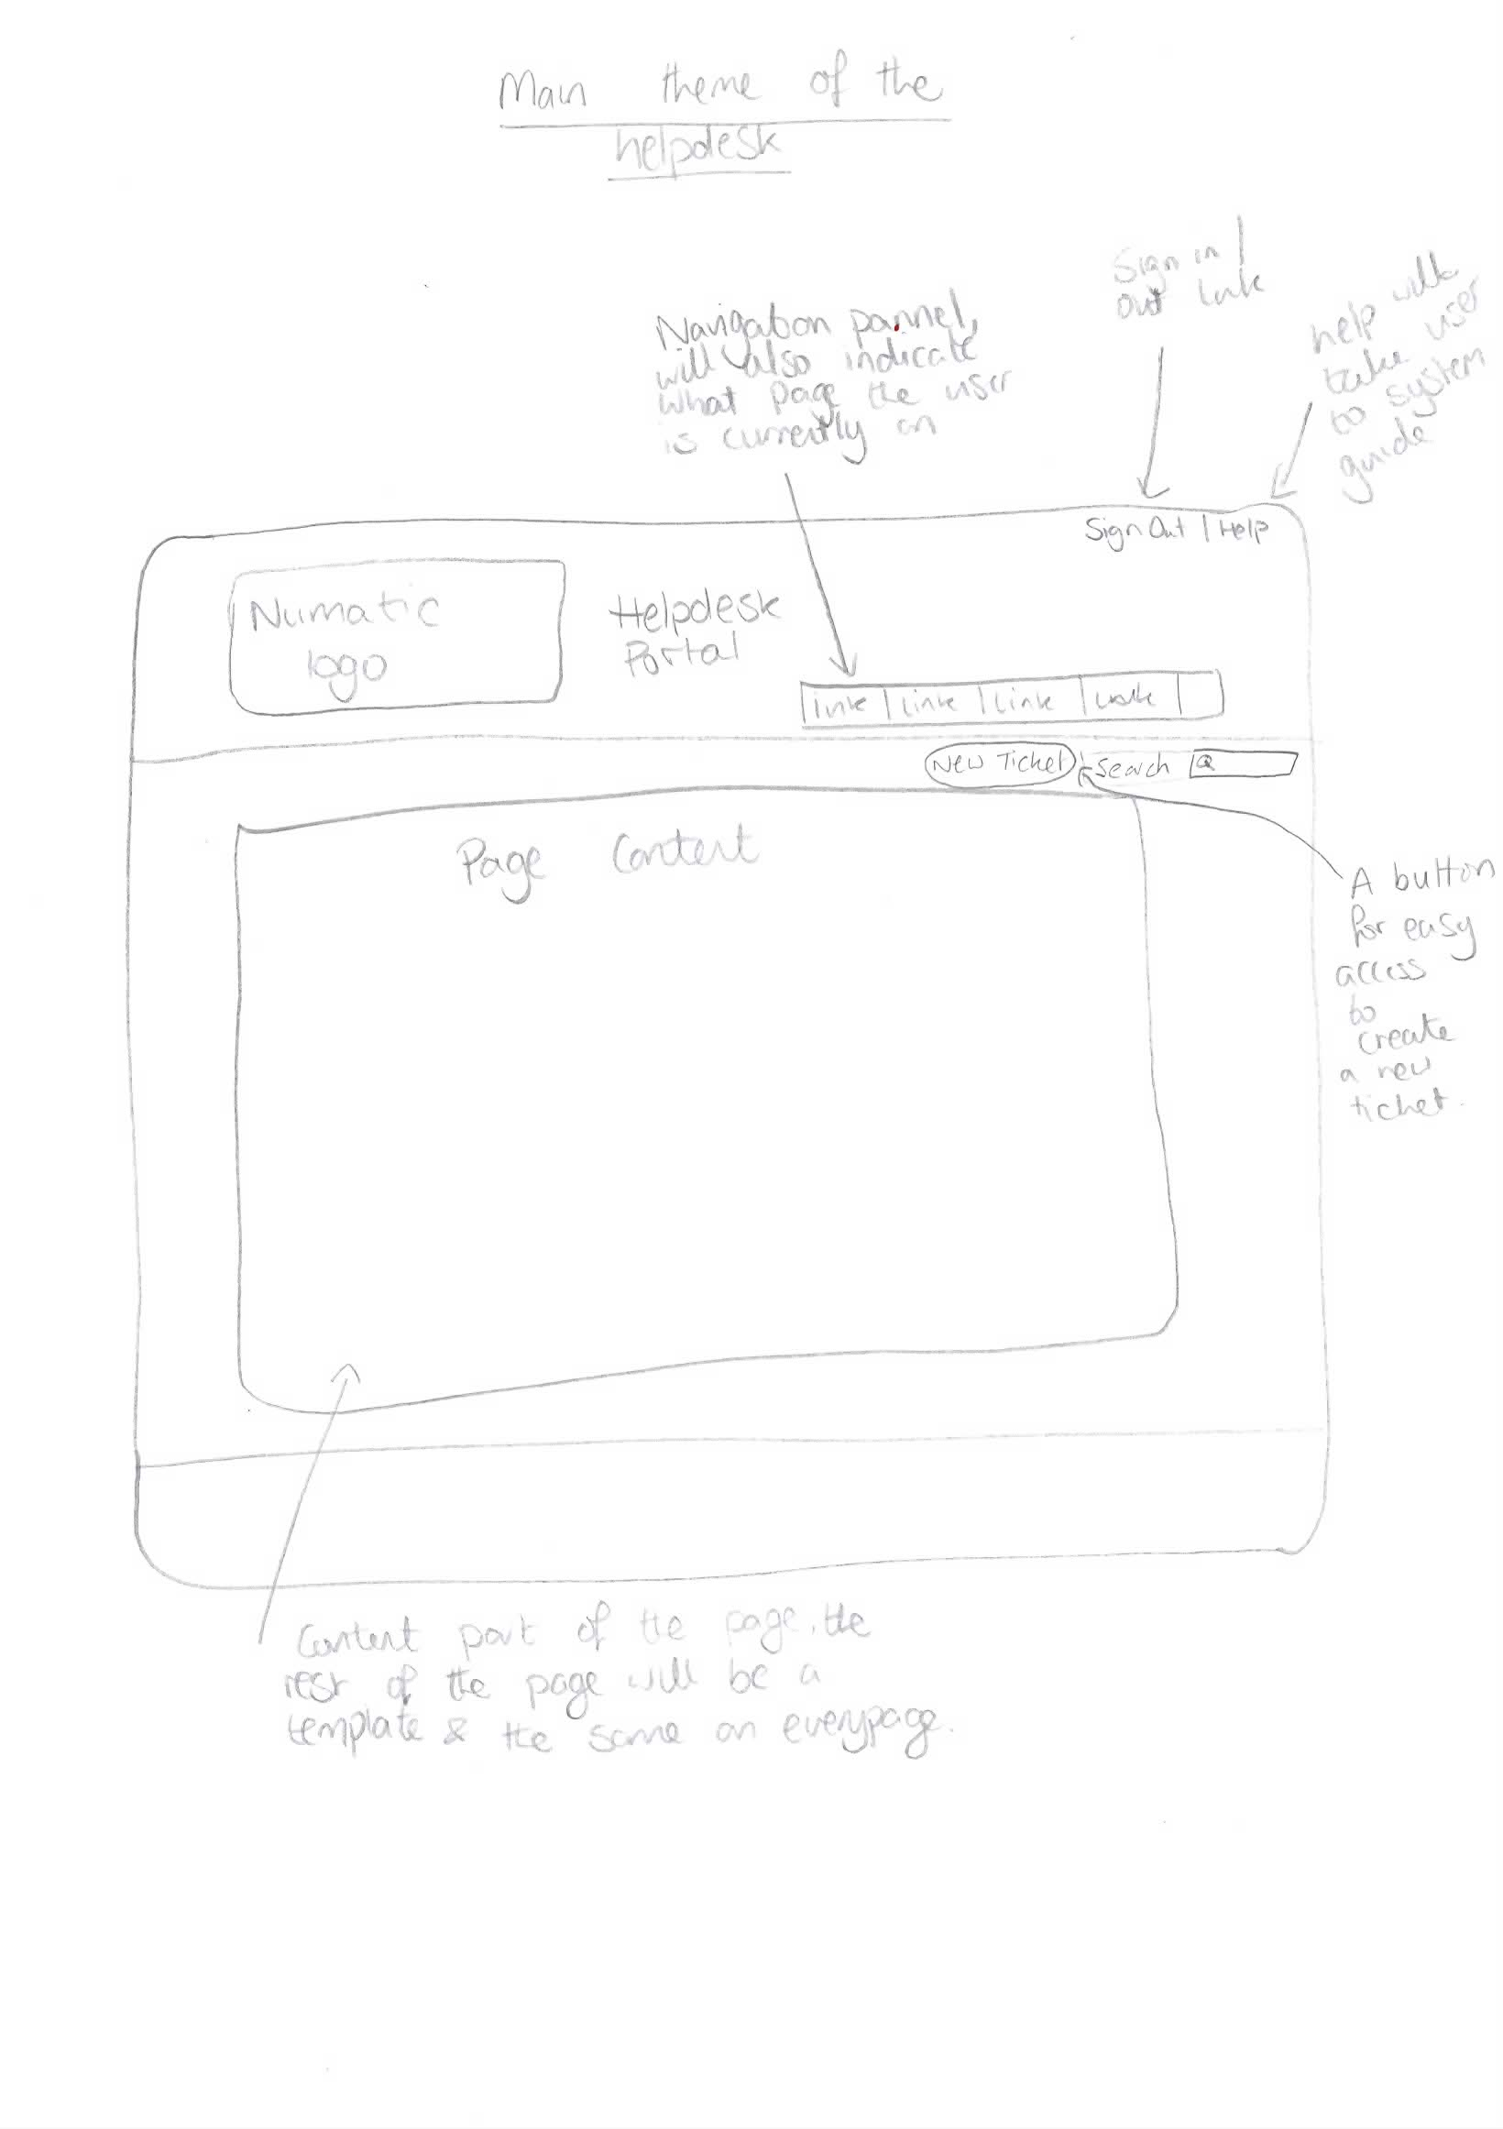

Main ticket page:

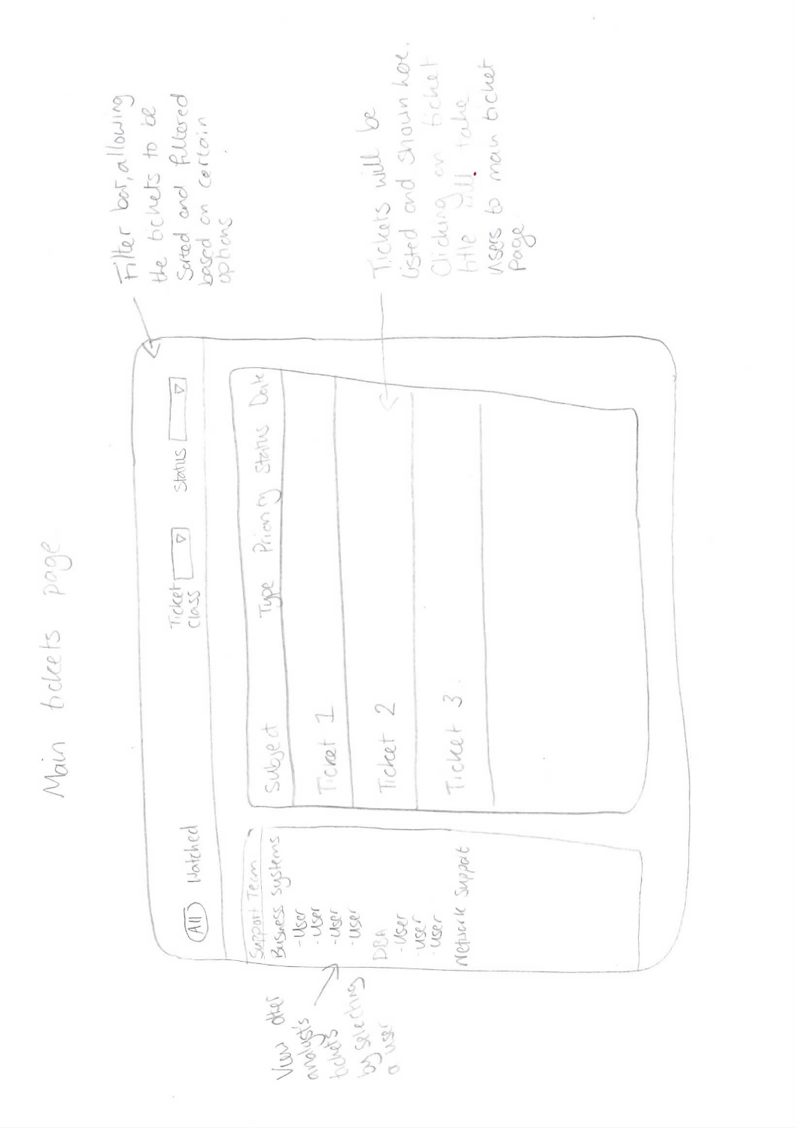

Individual Ticket View:

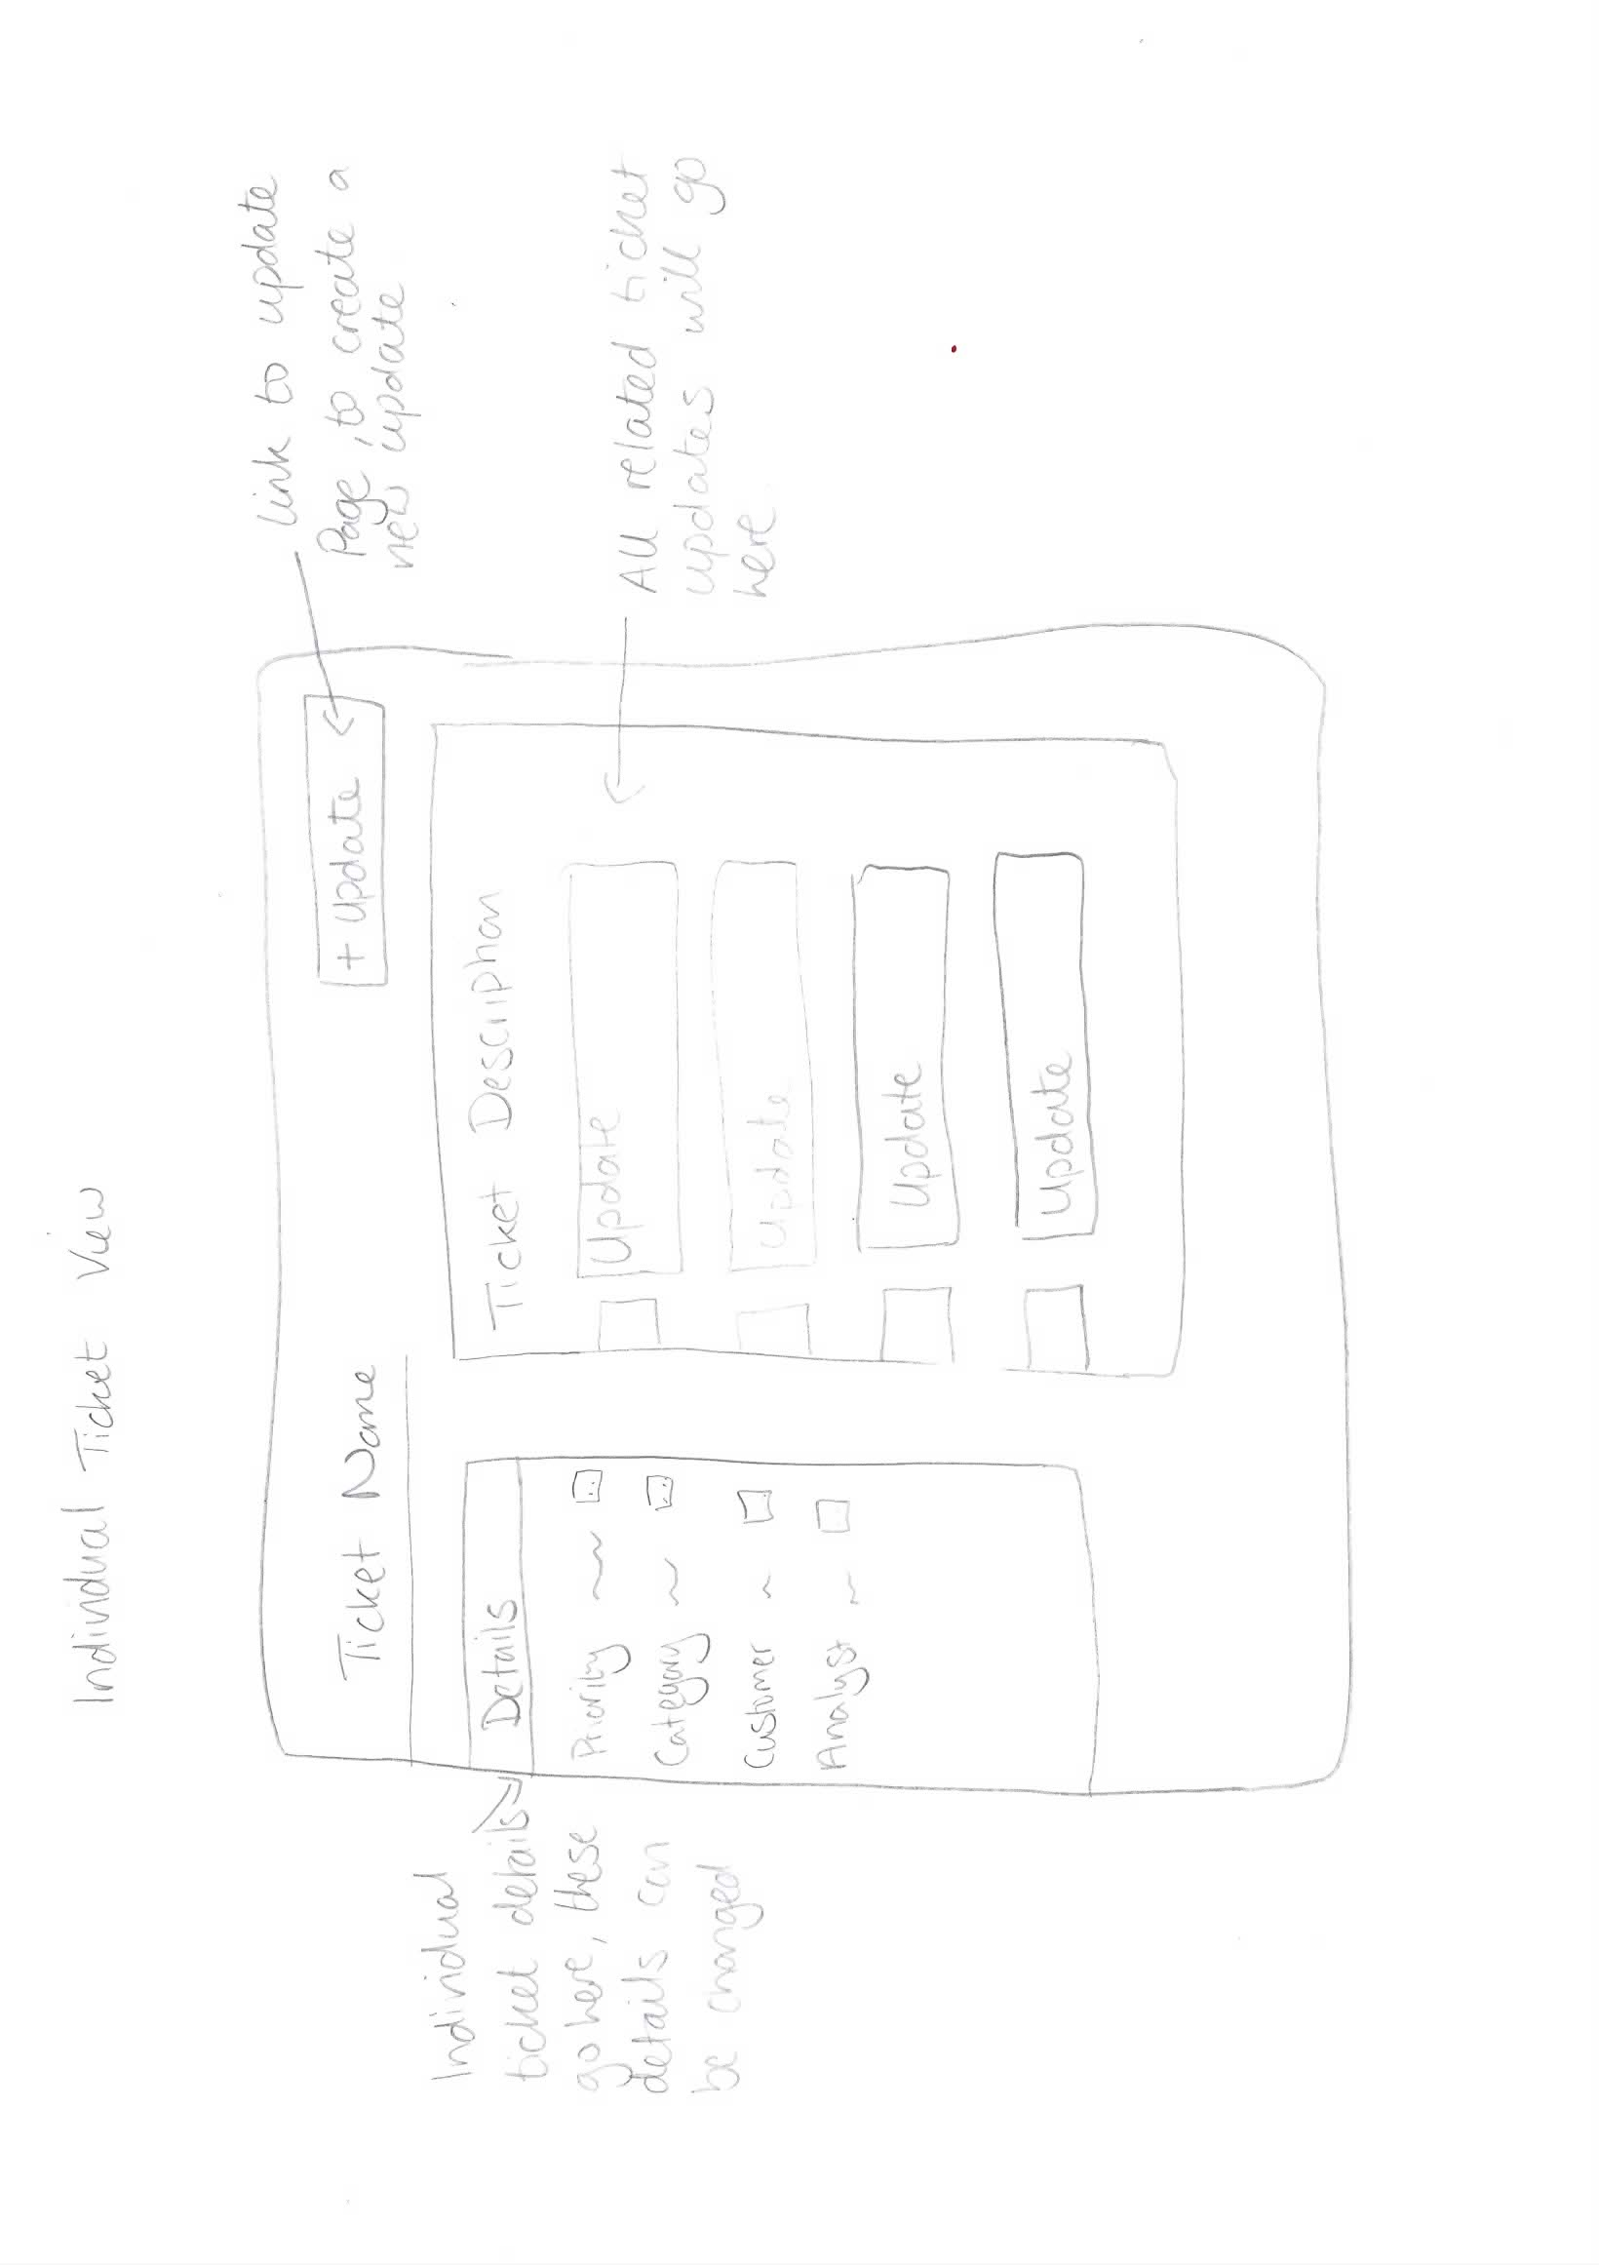

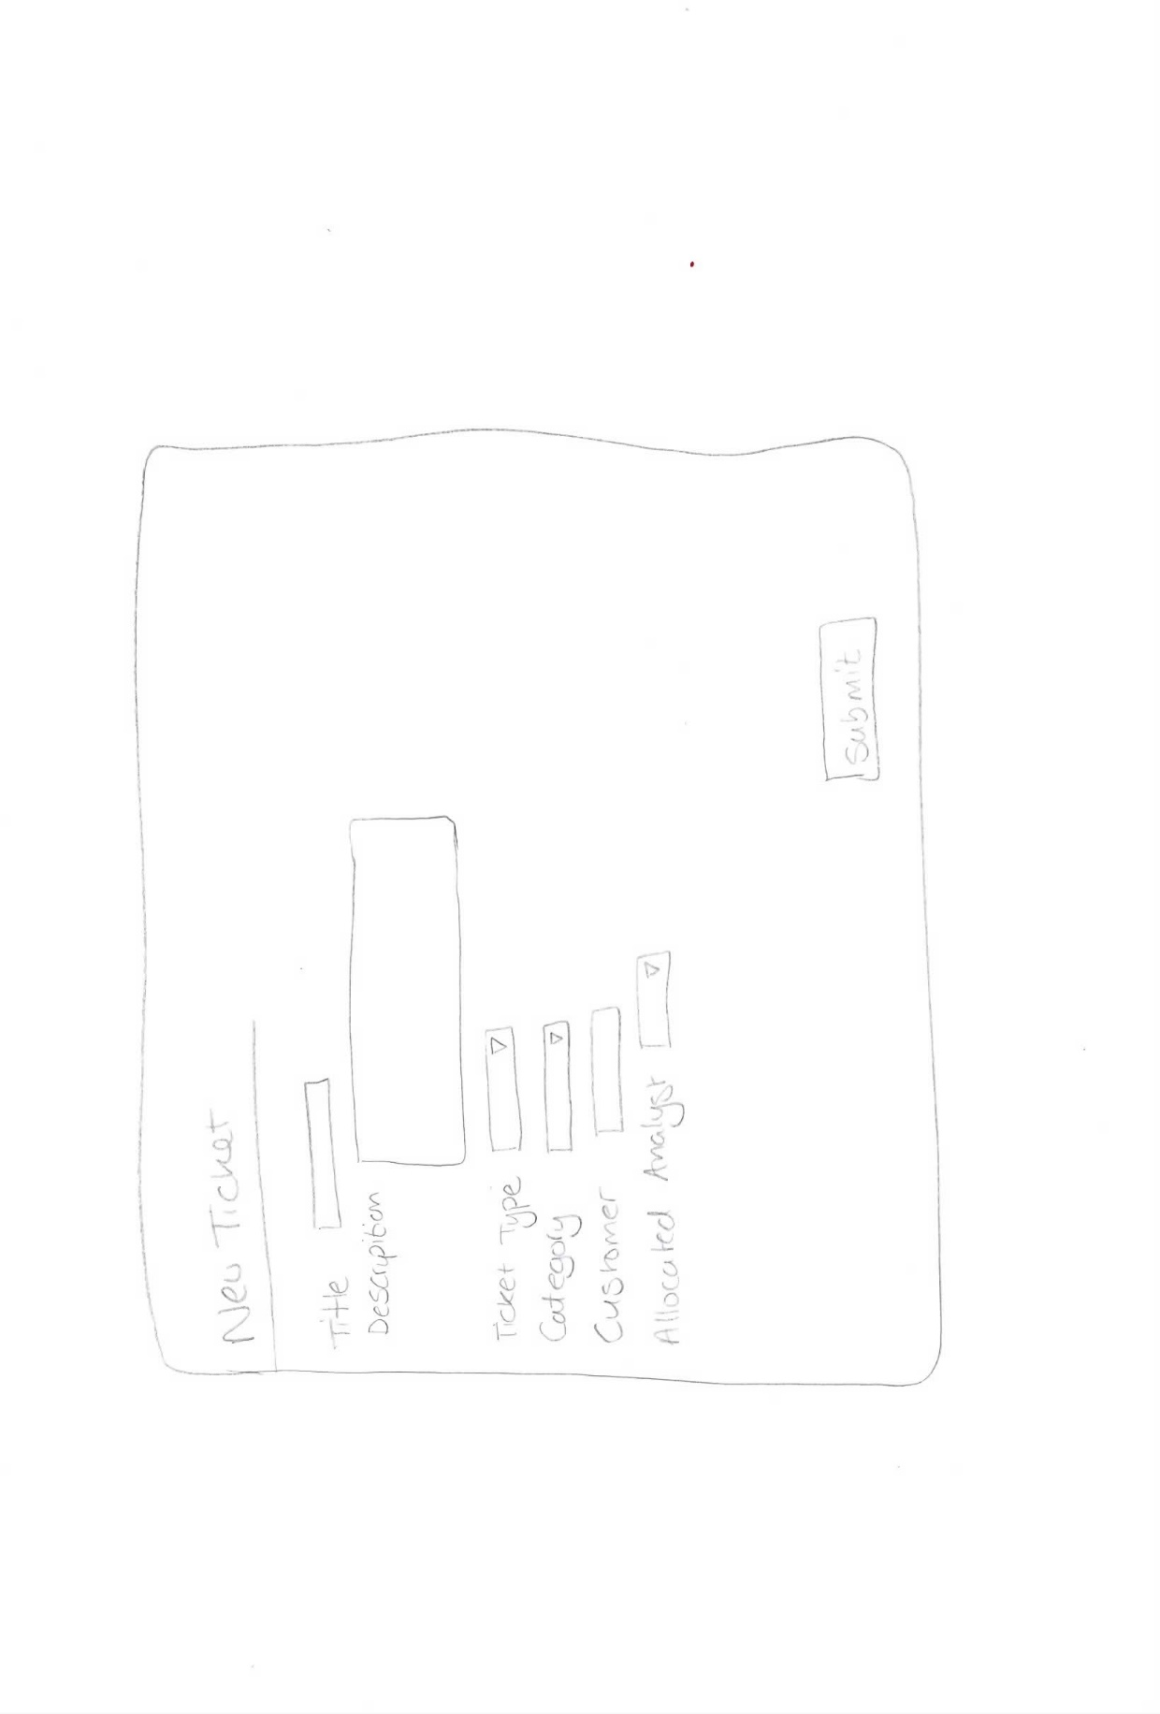New ticket page:

New Update Page:

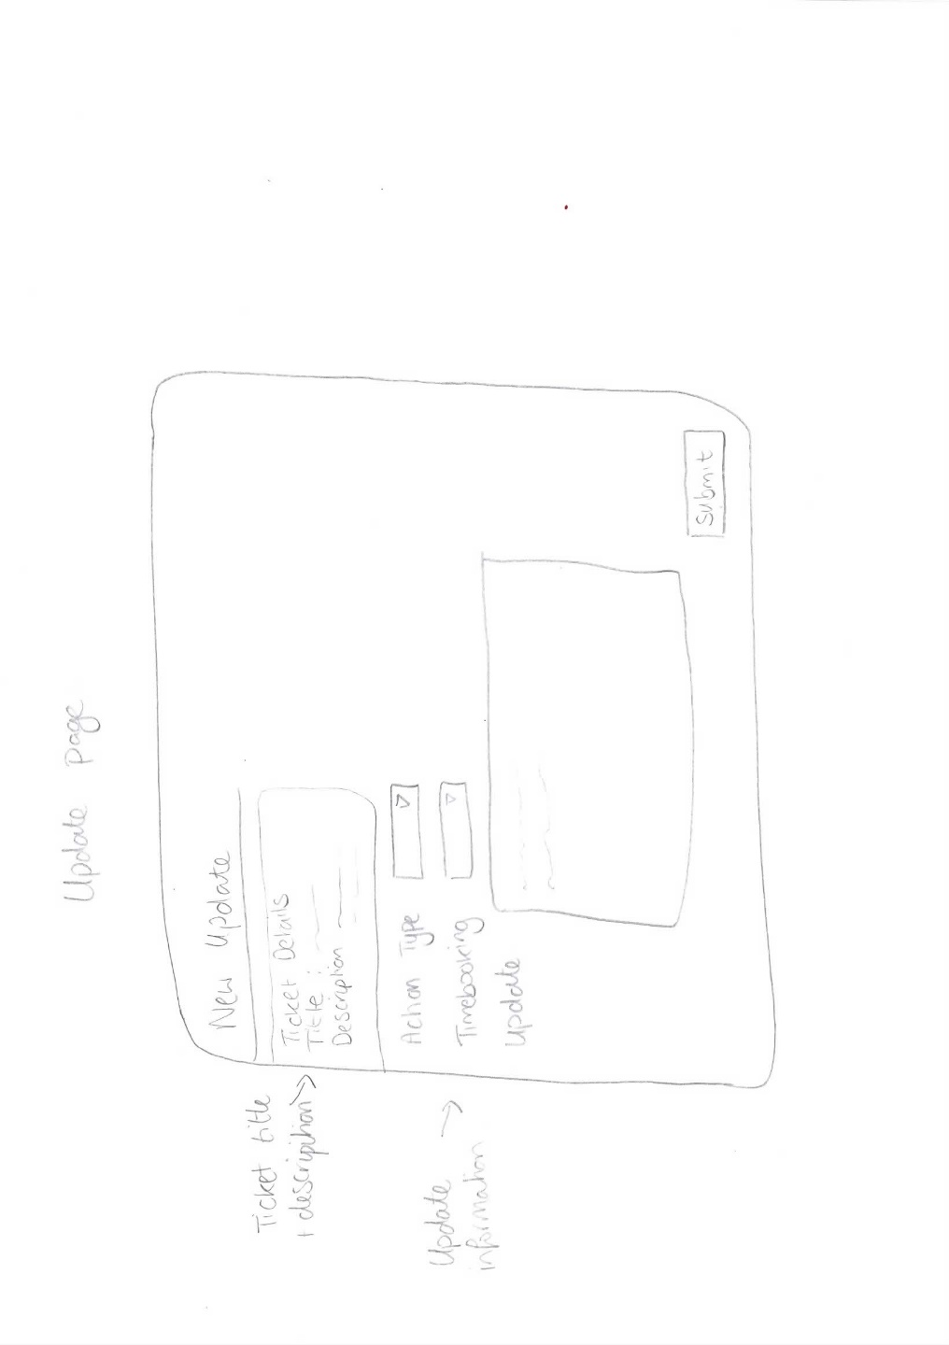

**Digital Design of theme:**

Further designs were created digitally to allow the client a better view of the look, including colours and logos, ensuring the client was happy before proceeding with the development of prototypes.



**Prototype of Design Theme**

Using HTML/ CSS to develop the overall GUI interface of the system, following the design specification and the paper based designs, this template was developed:

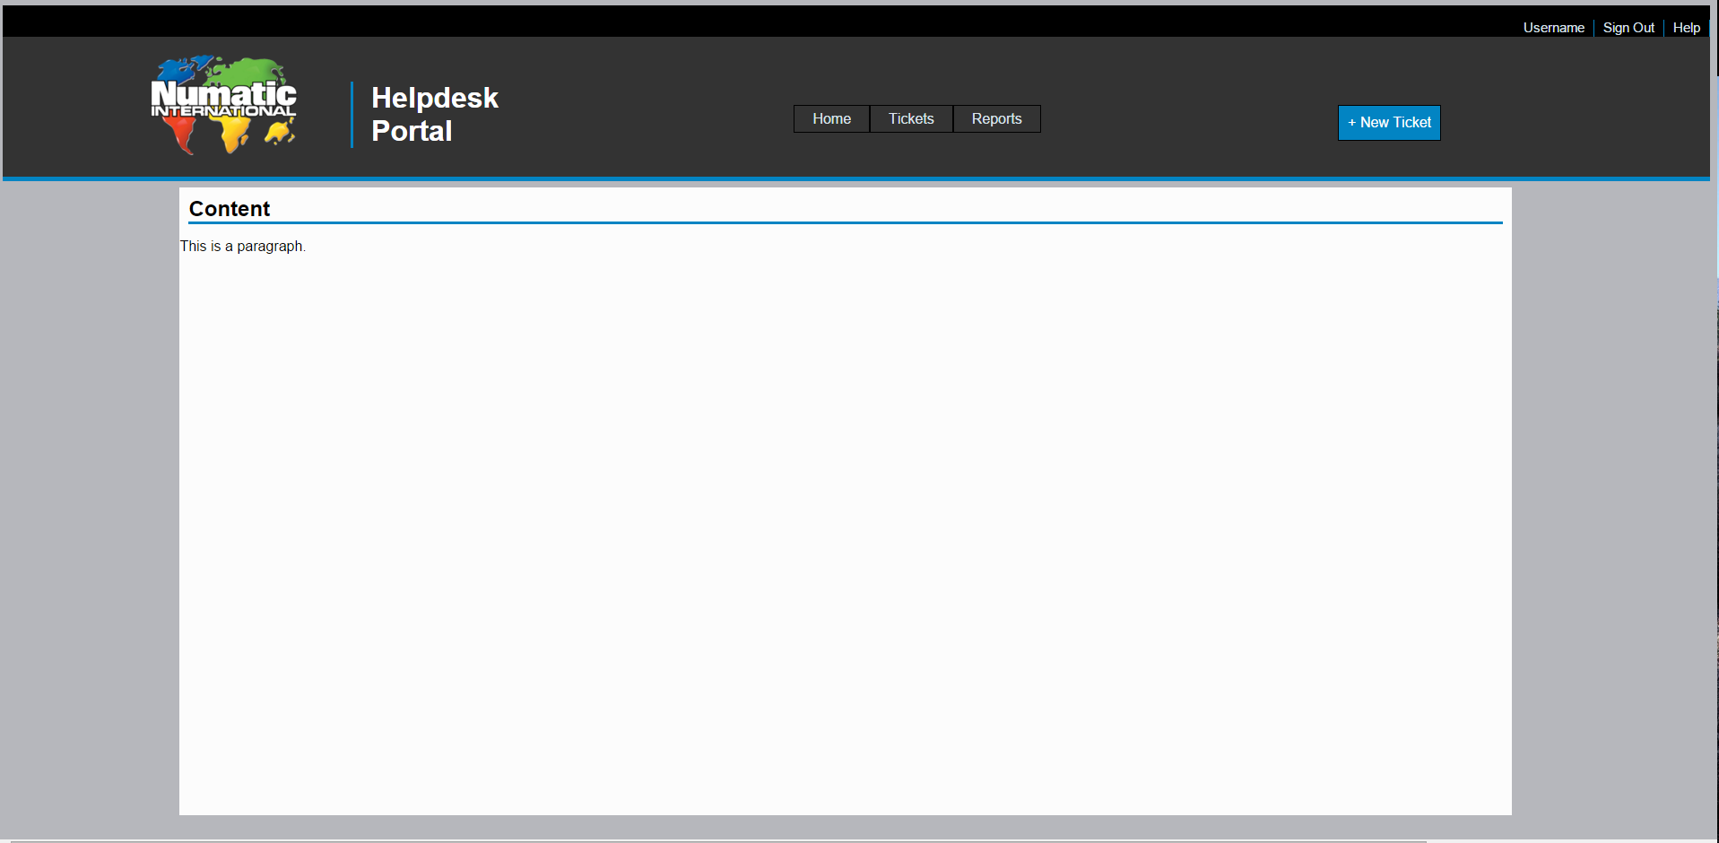

The template will now be used through the next phases of development.

**Client agreement**

The client agreed they were happy with the basic design of the system and liked the simple theme. They were also happy to allow slight design changes throughout the development of the system, should a change to the original designs be required.

# Appendix L – Original Entity Relationship Diagram

# Appendix M – Project Plan and Stage Plans

# Appendix – Project Fair Poster

